Two Northern Bands

The story of two regional brass bands, Stalybridge Old Band and Foden’s Band, over the period from 1814 to the 1920s provides an insight of a unique amateur musical world, its traditions and accomplishments.

Russell and Elliot’s The Brass Band Movement was the first substantive history of the brass band movement. Published in 1936, the text articulated an auspicious start to a new and remarkable working class movement. They wrote:
The early movement was bound up in the welfare movement, the enlightenment and education of the working classes, instrumental improvement, the popularization of orchestral music, circuses, and the pride of local patriotism. Its rapid and intensive spread in Britain was mainly due to the peculiar conditions of the industrial districts, although it was also prominent in the rural communities.
Despite being a national movement, the emergence of a brass band movement in mid-nineteenth century England was a largely northern phenomenon, brought about by social change, the rapid development of the railway network, industrialization, mass production of cheap instruments, hire purchase mechanisms and something which has been aptly described as the ‘sax-effect.’ Initially, a growing population of working people started to become involved with amateur reed bands.
These became popular with both players and audiences as the Industrial Revolution brought new life to a working population from around 1820, and bands began to convert to all-brass combinations as easy-to-play instrument became available and affordable. In this way many were able to engage in sophisticated music making for the first time.

Brass players often met in a common cause at the ‘brass band contest’ alongside sideshows, balloon ascents and other entertainments. Local band contests were popular in the North from the 1840s onwards and the largest of these was at the Zoological Gardens, Belle Vue, Manchester from 1853. This did so much to influence and disseminate ideas and attracted such a following that Belle Vue became a veritable ‘Mecca’ of brass banding .

There are many proud claims to be the oldest brass and woodwind ensemble, and ‘Stalybridge Old Band’ established in 1814 and still active is certainly one of these. A town band, the ‘New Band’ of 19 members of brass, woodwind and drums was formed by Thomas Avison (1796 - 1866) and played typical repertoire of the time such as ‘With Wellington we’ll go’ and ‘The Downfall of Paris’. It was scheduled to play at rally at St Peter’s Fields, Manchester on 16 August 1819, and only ‘a little thirst and a lot of good fortune’ kept the bandsmen from being seriously involved in what became known as the Peterloo Massacre. A full and fascinating account of this day can be found in the band’s self-written centenary history of 1914.
The band, like others, appears to have converted to being an all brass ensemble in the 1840s. It was self-supporting through its own contributions such as subscriptions and fund-raising events, and the band’s history sheds fascinating light on the times, the band’s training and repertoire. In the band’s history, Tom Wood, an elderly member who was in the band in his teens from 1848 recalled the importance of hobbies to working people,
During the Forties, bandsmen were surely live enthusiasts. Then there were no Trade Unions, no dreams of a minimum wage, or of eight hours work, eight hours play, &c. Instead, we worked twelve hours, wages low, very dear bread .., Band practice after twelve hours in the mill was surely a well-earned luxury. Music was nearly all in manuscript, and was very expensive, besides being very indistinct … Improved scoring for brass bands came much later, together with Band Journals and other aids … I got quickly among the classic composers, Handel, Haydn, Beethoven, Mozart, Weber, by studying vocal music … while Sykes and Cooper led others to Psalmody and quartett (sic) playing. Lip training, and double and triple tonguing was often done among the mountains.

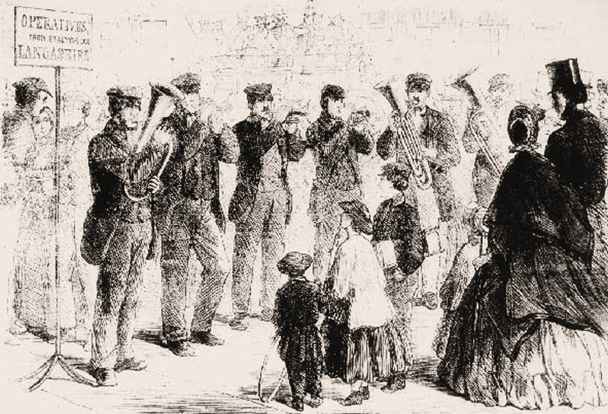Figure 1 – Stalybridge Old Band in the 1860s, permission Gavin Holman, Internet Bandsman’s Everything Within (IBEW)

The ‘New Band’ had become the ‘Old Band’ by the 1840s, and excelled at Belle Vue. Prepared by some of the leading ‘band trainers’ of the day for contests of extraordinary popularity, it won significant prizes from the 1860s. James Melling, one of the band’s conductors, was involved in the setting up of the contest at Belle Vue. He was clearly an influential figure, and either composed or arranged an early contest work, Orynthia, which has unfortunately not survived. He conducted several bands in the Manchester area, particularly the ‘City Royal Brass Band’, and was conductor-trainer of Stalybridge from 1859 – 61. During these two years he took the players to a short-lived National Contest at the Crystal Palace, Sydenham, as well as many more local events. It was reported in the Manchester Examiner and Times that 16-18,000 spectators and players attended Belle Vue by the third contest in 1855 and this number grew substantially throughout the century. This regional phenomenon and probably the lack of other ‘distractions’ in small villages may have contributed to the country’s best, so-called ‘crack’ bands being concentrated in the North of the country. Therefore, because lesser bands tried to emulate these ‘crack’ bands, competition was unusually stiff in this region.

By the end of the century there were amateur brass bands the length and breadth of Britain. Algernon Rose wrote in 1895:
There are upwards of forty thousand brass (and brass-reed) bands in the United Kingdom alone, and the master-composer has yet to arise who will immortalise himself by waking, in a classical sense, the soul of that mighty force…There is, nowadays, scarcely a mill, a factory, or colliery throughout the Midlands, North of England, parts of Scotland and Wales … which does not boast of its contingent of instrumentalists. Of all amusements for a mechanic, after his daily toil, supposing him to have the least liking for music, there is nothing so suited as the study of a brass instrument. It is easily learnt, calls for little exertion, and, through the emulation it causes, begets habits of abstemiousness.
Historian Dave Russell comments that the estimated numbers of bands at that time varied wildly, but ventured that any British community of more than 1000 inhabitants supported some type of band in the late 19th century. These bands played to cross-class audiences in public parks, and, in addition, played at many civic events, such as sports’ days and old persons’ treats. Local contests were very popular. Writing in 1901, Good Words reported that ‘brass band contests evoked white-heat enthusiasm in local people; they were important factors in the social life of the people, thousands of people took the keenest interest in them.’
Published arrangements for ten or more players meant that bands of all sizes and standards could make accessible and versatile music.

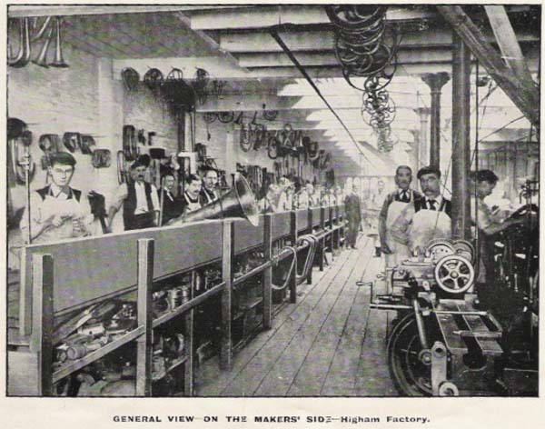IMAGE 2 – Higham’s of Strangeway, permission Gavin Holman, IBEW.
The music making was underpinned by significant commerce. For example, instrument maker Joseph Higham of 127, Strangeways, Manchester employed over 70 staff in 1892. The works had a branch office and show rooms at 84 Oxford Street, London, W. Joseph Higham described himself as a brass and military band instrument maker to the army, navy, volunteers, &c., &c. Higham’s advertisements offered representatives who could call upon the Band Committee with samples at a time convenient to them, with price lists and estimates on application. Algernon Rose advised on how to form a brass band in the 1890s, and crucially how to set up financial mechanisms in order to borrow funds to purchase such sets of instruments. At this peak of activity there were thirteen publishers of brass band music and periodicals and well over 200 annual contests throughout the country. In the North, for example, Huddersfield sported two band uniform tailoring companies, and Manchester two brass band journals. However, the musical motivation came from within the bands, then totally all-male. Whereas many of the earliest brass band trainers were ‘hired-in’ professional or semi-professional musicians, the finest of the late 19th century were products of the brass band movement itself. A nucleus of northern brass band conductors raised standards, standardized instrumentations and utterly ‘ruled the roost’ between 1875 and the First World War. Alexander Owen (1851-1920) was a dynamic self-made man who conducted ‘Stalybridge Old’ as early as 1869 - 70 and went on to take the Besses o’ th’ Barn Band round the world in the early twentieth century. Gladiatorial, dynamic figures like Owen were in high demand, and bands then and now could be fickle about their choice of conductors.

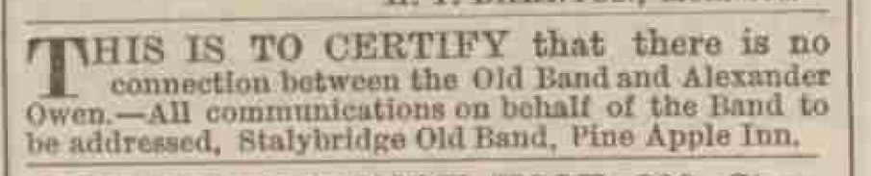Image 3 – extract from Ashton Weekly Reporter 1871

Another leading figure, John Gladney (1839-1911) was a former professional clarinettist in the Hallé Orchestra who proceeded to dedicate himself to brass bands and became regarded as the ‘father’ of the brass band movement. This esteem was such that Owen named his eldest son Gladney Verdi Owen (b. 1897). The participation in contests was almost certainly the most serious passion of the bands, and highly lucrative for the best bands and their trainers: in 1876 alone ‘Stalybridge Old’ or its soloists participated in nineteen contests; and Gladney and ‘Stalybridge Old’ won £138. 17s. prize money in 1881 and £172. 09s. in 1882.
Historian Eric Hobsbawm in ‘The Invention of Tradition’ describes common trends throughout Europe between 1870 and 1914, arguing that traditions that seem old can be more recent than thought . Brass bands had by this point widely adopted certain traditions and customs, many of which still prevail; a quasi-military dress code and deportment is still commonplace; standardized and ordered seating arrangements is the norm; change in instrumentation has been resisted since ca 1875; dress of the conductor was non-military and professional at the top level. Today’s rehearsals are still referred to as ‘band practice’, a possible legacy of the band trainer. The custom of calling rank-and-file cornet players, for instance ‘third man down’ regardless of gender shows little sign of abating, seemingly unconnected to either sexism or women’s emancipation. Possibly for these reasons, this movement, locked in time, has proven irresistible to social historians and other interdisciplinary academics. Trevor Herbert discusses how in the 19th century, brass bands were influenced by high art music and tastes, but became more and more culturally contained as original repertoire and an emphasis on contesting separated the brass band world from the mainstream of musical development. The banding world continues to be ambitious, fastidious and proud, if rather insular. Continued symbols of struggle and success are displayed in detailed regular global league-tables in The British Bandsman and other periodicals, and stewardship of magnificent silver trophies that are displayed at the concert performances of successful bands.
By 1890 the national banding movement demonstrated significant incorporation, mirroring the organization and development of football, a parallel working-class cult. Hobsbawm writes of football’s ‘League, the Cup, with its annual pilgrimage of the faithful for demonstrations of proletarian triumph in the capital…the ‘supporters’ and their culture, the ritual rivalry’. This has applied to the brass band culture since the mid-nineteenth century, and is strongly relevant today.
However, whereas the nineteenth century symphony orchestra or opera had a largely middle-class following, the brass band (and the amateur choir) was accessible to all, the musicians replicating middle-class culture on their own terms. Laurence Levine writes of parallels in American culture in ‘Highbrow / Lowbrow’, where operatic music could even be considered simultaneously popular and elite, with ‘a distinction more functional than aesthetic’.
In this respect, in addition to its competitive success, ‘Stalybridge Old’ did a lot to advance its town’s cultural life. The bandsmen staged an astonishing 79 annual community concerts up until 1893 ‘as promoters of annual concerts which were remarkable for quality and for continuity.’ These were held at the Stalybridge Mechanical Institution (founded 1825), the Town Hall or the Drill Hall (People’s Hall) and grew from tea party type affairs into more public ‘Grand Miscellaneous variety events’. The band employed many and varied soloists, such as a Mr. Creed Royal performing on ‘Siccano’s Patent diatonic Flute’ and notables from the Carl Rosa Opera Company. The celebrated tenor Joseph Maas appeared in 1881 and 1884, and ‘famous prima donna’ Madame Marie Rôze, sang ‘Softly sighs’ from Der Freischütz, ‘All in a Garden fair’, the Habanera from Carmen, and in a trio from Faust. But the outlay for such artists was high, generally between £50 and £60, and in the 1890s this series of concerts wound down and petered out because of low returns on fees. This enterprise and wide repertoire was an impressive cultural contribution to a proud and prosperous working-class town, and mirrored other industrial communities of a similar size in the region such as Slaithwaite and Bacup.. Indeed, brass band repertoire of the late nineteenth century was typically very inclusive, comprising marches, sacred hymns, solo or popular items, and selections of Italian opera and even transcriptions of Wagner from the 1870s. Substantive original works written for brass band were to be introduced at a later stage.

In 1900 Britain was recognized as the world’s leading economy in a ‘golden age’ due to its unsurpassed economy, trade and heavy industries. Despite this national standing with increasing wages and cheaper food, from 1901 working class groups, particularly the miners, saw deterioration in fortunes, and this was reflected in the activities of the bands. By 1914 this situation had progressively deteriorated, with working class families spending proportionately more of their income on food.

It was during this adverse period that the Foden’s Band was founded. ‘Foden’s’ was radically different from ‘Stalybridge Old’ because a factory owner’s family financially supported it, with clear benefits to the players. A local band was founded in 1900 amongst celebrations of the relief of Mafeking, and after a few growing pains and fall-outs, became called the Elworth Band. The band was adopted just prior to the coronation of King Edward VII in 1902 by Edwin Foden (1841–1911); proprietor of a local steam wagon works in Sandbach. He eventually re-named the ‘Foden Motor Waggon Works Band’, which after some modest beginnings, improved spectacularly and achieved Championship Section status, winning the British Open Championships in 1909, 1912 and 1913.

Its unique and rapid rise in standards was probably largely due to the Foden family’s initiative in appointing the best band trainers of the day. Foden’s Band has the continued benefit of a ledger, kept from its foundation until 1974, recently compiled by Stewart Green with additional information from long-serving members of the band into an accessible account on the band’s website, a remarkable source of highly detailed information of the times which sheds light on the earliest developments.

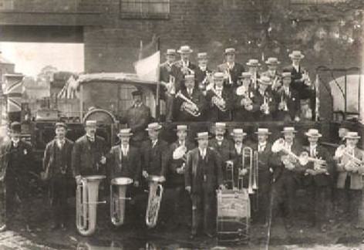Image 4 – Foden’s Band in 1904 with Edwin Foden seen in profile on the right hand side, permission Gavin Holman, IBEW.

In 1902 William Rimmer (1862-1936) was the very best ‘trainer’ in the business that Edwin Foden could hire for his band, and Rimmer had a standing and power difficult to question. In 1907 Rimmer asserted that the band was being held back from its potential by the mixed standard of its players. For this reason Edwin Foden was compelled to call in his two sons Edwin Jnr. (E. R.) and Billy, along with his son-in-law Sam Twemlow to inform them that they were to be sacked from the band. In total nine members of the band were replaced, and William Rimmer subsequently led the band to victory in 1909 in their first attempt at the ‘British Open’ contest at Belle Vue, an achievement still marvelled at over a hundred years on. The prizes included £128. 16s. as well as a prize cornet and three medals for individual contributions. After this pinnacle of achievement, Rimmer chose to retire from conducting brass bands at contests, and dedicated himself to composition and work with the fine municipal band in his hometown of Southport. He recommended to Foden that his successor at Sandbach be William Halliwell, who proved highly successful in carrying on the Foden’s Band winning streak. However, Rimmer remains the band’s acknowledged artistic founder; to this day the band’s ‘calling card’ is a famous Rimmer march written for Foden’s, The Cossack (1904).

Rimmer and Foden went to great lengths to succeed, and talent spotting was a key strategy. Edwin Firth, an exceptionally talented young solo cornet player was a key acquisition. In 1908 Firth was spotted when he won a solo contest at Mytholmroyd, and two other brass band notables - Fred Mortimer from Hebden Bridge who won second prize and Arthur Webb of Houghton Main who won third prize – were to play very important roles in the Foden’s Band of the future. Firth was from a great brass band family and made his London debut as a solo cornet playing with the Skipton Prize Band at the Crystal Palace brass band contest in 1902, aged 13. Under his tutors Alexander Owen and William Rimmer, he achieved one success after another. Foden required and was granted parental consent in 1908 because Edwin was still a minor at age 20. Furthermore, in these times of hardship siblings were often required to stay at home and work to make ends meet. Foden suggested an in-house trade apprenticeship, but Edwin continued training as a watchmaker and as a musician. Later, he settled on a combination of a job in Foden’s offices, plus a small remuneration for playing with the band. Meantime, his contribution to the band was exceptional, with many solo appearances and a fine solo recording.
Always demanding superiority for the band in both musicality and deportment, even despite a recent redeployment to a non-playing capacity, E. R. (Edwin Richard) Foden (1870 – 1950), the founder’s son, ordered a new set of uniforms in a fashionable ‘Prussian’ style. This was fortuitous, because in 1913 the band had the honour and opportunity to perform to King George V and Queen Mary as part of their Royal tour to see the Industrial North, based at the residential home of the Marquis of Crewe. A special programme was compiled, and the band sent on a Foden’s steam wagon on the morning of 23rd April to perform in front of Crewe Hall. This was well received. Impeccably presented in their ‘Prussian’ attire, the bandsmen were commanded to play again the following morning.
The outset of the First World War led to abrupt and profound changes in priorities, and a drastically changed social climate, in which context Foden’s Band naturally endeavoured to help the war effort. Local concerts raised modest funds to help the National Relief Fund. A concert reported in the Nantwich Guardian described patriotic musical items such as Firth playing ‘Rule Britannia’, and the review continued with patriotic reports on the care of Belgian refugees at Sandbach. It goes without saying that the Prussian-style uniforms and anything similarly Germanic was put into cold storage, but the uniforms experienced one last exceptional parade.
Foden’s band records mention a Sandbach May Festival on 27 May 1916 (teas provided) where a first prize was won by a float in the image of a German Zeppelin, made up by the joiners of Foden’s works, mounted on a steam wagon. Here the firm’s joiners wore the “Prussian” uniforms, and stood amongst soldiers. A commemorative postcard of the float was published at the time:
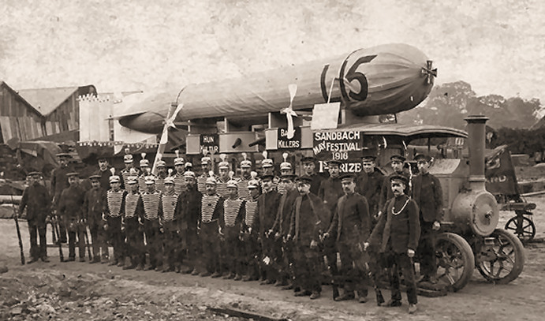Image 5 – Foden’s May Festival Float with Prussian-style Uniforms in 1916, permission Gavin Holman, IBEW.
Edwin Firth was called up for duty in 1917, and the Chester Chronicle wrote about one of his last park concerts with Foden’s, describing him as “one of Chester’s musical idols”. Firth played the Fée des Eaux polka by Saint-Jacombe to ecstatic applause. The review was innocent in its foreboding;
Of course he had to respond to an encore, and whether it was accidental, designed or prophetic, we cannot say, but his choice of Tosti’s “Good Bye” was at least a significant coincidence seeing that Mr Firth was called by the military to appear at Chester Castle on the following Wednesday. We understand that Mr Firth has got an extension otherwise it would have been awkward for Foden’s to be without their chief cornet player in the great Belle Vue Brass Band contest which is to be take place at Manchester tomorrow (Saturday).
Tragically, Edwin Firth was killed on the Somme the following June alongside his comrades by an exploding shell, leaving a young wife and a child he had never seen.
The rise and national success of Foden’s Band was remarkable, but in the early twentieth century the brass band movement as a whole saw a period of decline due to a changing social world: steam organs replaced some bands on proms, such as Blackpool’s in 1912; the advent of long-running films such as D. W. Griffiths’s Birth of a Nation enticed village inhabitants to travel to bigger social centres in 1915; and further fads and fashions, such as the roller skating craze of 1909 deprived some bands of their membership. Changes in leisure and how people used their free time meant that bandsmen became less enthusiastic about music-making.

The brass band by then had lost some of its initial functions; for example it no longer provided dance music . Indeed the music hall, ragtime, the tango and jazz passed the brass band by – further contributing to the hypothesis that high art cultural models generally ‘fed down’ to the brass band world. A consequence was that the brass band began to be regarded curiously old-fashioned from the outside.
However, Belle View continued to hold its magnetic appeal. By chance, a London entrepreneur and fairground proprietor, John Henry Iles (1871-1951) visited the Belle Vue contest in 1898, and by the end of that year had eagerly bought out R. Smith & Co., the leading specialist publishing house and The British Bandsman, the leading periodical, as well as the very contest. After enlisting the support of no less than Sir Arthur Sullivan in promoting a brass band concert at the Royal Albert Hall in support of the servicemen of the second Boer War, Iles set about reviving a National Brass Band Contest at Crystal Palace, London in 1900, driving the whole brass band movement on.

Iles’s concept of the National Championships tell us much about the times and common currency of brass band repertoire. Brass band repertoire was formerly reliant upon middle-class tastes established in the mid-nineteenth century and many parties, not least the editors of brass band journals, were lobbying for a change in brass band repertoire. Gems from Sullivan’s Operas No 1 (1900) and subsequent contest selections reflect thinking which may have been influenced by either modernization or by commercial interest, but now seem curiously old-fashioned. Gems of Chopin (1906), Gems of Schumann (1907), Gems of Schubert (1910) were experiments which possibly signal of the end of a long tradition. One letter of many to The British Bandsman in 1912 sums up a common concern:
It is a great pity that the members of the brass band fraternity are looked upon as outcasts as far as the majority of present day composers are concerned. This is surely their loss as well as ours: if some great composer would turn his attention to the possibilities of the brass band, he would not only confer a blessing on the brass band world, but on the public and, last but not least, on himself also.
This suggests that the contest movement was running out of inspiration, but the most enduring band music of the following years written for contesting proved to be more specialized and bespoke. J. H. Iles’ new initiative was to commission original works for his Crystal Palace National Championship in London. A work by an aspiring composer, Percy Fletcher (1879-1932) Labour and Love was submitted in 1913, and this is commonly regarded as marking a major turning point in brass band evolution. Russell and Elliott described this as ‘a tentative beginning – but Labour and Love marked the first important step in the emancipation of the brass band as a musical medium.’ Furthermore, the work described as being based on ‘a rather naïve programme designed to capture the attention of the working-class musician’ was the impetus for a new repertoire. But even the adoption of this one original piece in 1913 needed some political manoeuvring by Iles, who had to ‘let go’ of his chief music editor William Rimmer to instigate change. A subsequent test piece of 1921, Cyril Jenkins’ Life Divine elevated playing standards through its technical challenges, and is still frequently played today.

Iles’s vision led on to an annual succession of new works for Crystal Palace, which in the late 1920s and 1930s included works by Gustav Holst, Granville Bantock, John Ireland, Herbert Howells and Arthur Bliss, fashioning what became regarded as a veritable ‘golden age’ of the brass band. This was mirrored by six test pieces for Belle Vue, written by Thomas Keighley (1870 – 1935), born in Stalybridge and a long-serving member of staff at the Royal Manchester College of Music. These include Macbeth (1925), the first original test piece written for Belle Vue, and Northern Rhapsody (1935), but unfortunately Keighley’s brass band music has not enjoyed a lasting popularity as part of the repertoire.

The first decade of the twentieth century presented unusual opportunities to the bands of Northern England. Iles took Besses o’ th’ Barn Band on what has been described as a ‘missionary tour’ of UK in early 1904. In June 1905 the band played to the Royal Family in Windsor, followed by a high profile charity visit to France in 1906-7. A follow up world tour, masterminded by Iles, with director Alexander Owen, visited America, Canada, Hawaii, Fiji, New Zealand and Australia. The trip was made possible because they were engaged to play for one month at the International Exhibition, Christchurch, for which Iles received $12,500. Black Dyke made a similarly ambitious tour from June to November 1906 of Canada and USA conducted by John Gladney (then aged 67) , even preceding the London Symphony Orchestra who toured USA and Canada with conductor Arthur Nikisch for three weeks in April 1912.
But despite this eclecticism and enterprise, the band world never followed trends such as ragtime or jazz, nor attempted to emulate the musical styles of Debussy and Ravel, Richard Strauss or Bruckner. A period of innovation of new musical languages and scoring techniques followed much later in the 1960s and 1970s and even then instigated sharp dissent and strenuous debate within a most conservative culture.
Brass bands have come and gone, but in a general decline from the turn of the century, the total number of British bands dwindled to around.5000 by the 1930s, comprising by then a more closely-knit community of participation, contrasted with the ‘rapid and intensive spread’ and surge of mass-entertainment of the nineteenth century. For example, Kingston Mills Band from Hyde was active from 1837 – 1945. It won many prizes, conducted by Owen, Rimmer and others, but subsequently disappeared. However, Stalybridge Old Band survives on in 2017, now in the third section and still active both in the local community and in brass band contests. Foden’s Band continues to be ranked consistently amongst the top ten brass bands of the world and since the 1980s has been sponsored by other partners. The last branded Foden’s truck was manufactured in 2006 by an American firm, PACCR Inc.

Looking back at earlier banding days, the historian Reginald Nettel wrote in the 1940s of brass bands of the Industrial Revolution:
The failure of brass bands to become musically great in spite of their fine technique is historically interesting. Their history runs true to form … It was this association with processions of working-class organisations that stood in the way of their fuller recognition – that and their convivial background, for blowing is a thirsty job, and we know from Hogarth what the humanitarians thought of ‘houses of intemperance’. ‘
However, subsequent scholarship and understanding of the British brass band from the late 1970s onwards perhaps place Nettel’s reservation in a much wider context. Accounts of rowdiness and of high spirit are not surprising in a competitive world amongst the supporters’ culture and the ritual rivalry, as mentioned above. However, this was all largely reported on as an external view of the working class at leisure. Many periodicals sided with this as a detriment to the movement, but the irony is that band periodicals treated bandsmen’s roughness as a source of ‘gentle’ humour. Perhaps this was because of the band world’s overwhelming passion for music making combined with the unique opportunities that attracted a multitude of participants and their public in the long nineteenth century? This was nowhere more evident than in the North of England, with the Zoological Gardens, Belle Vue, Manchester the epicentre.

J. F. Russell and J. H. Elliot, The Brass Band Movement (London, 1936), jacket note.
The inventor and manufacturer Adolphe Sax (1814-1894) exhibited the saxhorn, an early valved brass instrument, at Paris in 1844. These instruments were popularised in part by the performances of the Distin family ensemble, and their use spread rapidly. This phenomenon was described as the “sax-effect” by Trevor Herbert at the opening of the Sax200 conference in Brussels on 4/7/2016.
T. Mutum, ‘Belle Vue, Thanks for the Memories!’, The British Bandsman, 5890 (2015), 13-15.
Stalybridge Band, Stalybridge Old Band, (Stalybridge, Geo. Whittaker and Sons,1914). This can be found on the website < www.ibew.org.uk >.
For further insight into hobbies of working people see R.McKibbin, ‘Work and Hobbies in Britain, 1880-1950’, in, The Ideologies of Class: Social Relations in Britain 1880-1950 (Oxford, 1994, this edition, Oxford, 1999), pp.139-136
Stalybridge, p.4
Manchester Examiner and Times, September 8, 1855, p.6.
A. S. Rose, Talks with Bandsmen: A Popular Handbook for Brass Instrumentalists (London, William Rider, 1895; facsimile with an introduction by Arnold Myers, London, Tony Bingham, 1995), introduction, pp. xi,xii.
D. Russell, Popular Music in England, (Manchester University Press, Second Edition, 1997), p. 205.
T.W. Wilkinson, “Brass Band Contests”, Good Words, 42 (December, 1901), p. 593.)
Rose, pp. 303-304.
Rose, pp. 356 – 377 lists extensive detail in a Bandsman’s Directory.
Ashton Weekly Reporter, and Stalybridge and Duckinfield Chronicle, 11 Feb 1871, p. 1.
E. Hobsbawm, “Mass-Producing Traditions: Europe 1870-1914”, in E. Hobsbawm, and T. Ranger, (eds.), The Invention of Tradition (1983), pages 263–307.
Herbert, T, Nineteenth Century Bands, pp 64-67, in ed. Herbert, T. The British Brass Band: A Musical and Social History (Oxford, Oxford University Press, 2000).
The British Bandsman was founded in 1887 and is still published today. See Hailstone, A., The British Bandsman Centenary Book (Baldock, 1987).
Hobsbawm, op.cit, p. 288.
L.W. Levine, Highbrow / Lowbrow, The Emergence of Cultural Hierarchy in America (Cambridge, Massachusetts, Harvard University Press, 1988), p. 104.
Stalybridge p.13.
This was probably Siccama’s Diatonic Flute of 1846, which retained an old system of fingering adopted by Joseph Richardson (1814-1862). Rudall Carte manufactured Siccama flutes as late as 1904.
National Archives “The Golden Age?”, www.nationalarchives.gov.uk>polecom3
The name of the band was changed to ‘Foden Motor Wagon Works Band’ in 1906 and subsequently to ‘Foden’s Motor Works Band’ from 1911 to 1979, when the name ‘Foden’s Band’ was adopted.
I acknowledge kind permission from Foden’s Band to use information from www.fodensband.co.uk/history.
The Latey Committee’s recommendation that the age of majority be reduced from 21 to 18 was ratified by Parliament as late as 1970.
Nantwich Guardian, 25 September 1914.
This event was described in M. Eddison and J. Hopkins, Cheshire Life (7th edition), (Place of publication, The History Press Ltd, 2007)
Chester Chronicle, 01 September 1917, p. 2.
Russell and Elliot (1936): 236.
T. Herbert,, Nineteenth Century Bands, pp 64-67, in ed. T. Herbert, The British Brass Band: A Musical and Social History (Oxford, Oxford University Press, 2000).
The Prophet, British Bandsman, 12 October 1912, p. 334.
Russell and Elliot (1936), pp. 180-181.
Some sources cite his date of birth as 1889. This is not correct. His date and place of birth is established as 1870, Stalybridge, in the 1911 census.
See R. Newsome, 150 Golden Years (Norwich, Page Bros., 2005), pp. 65 – 70.
J. H. Iles introduced categories of bands in his Crystal Palace National Championship in London, and this remains similar to the classification of football teams, with Championship Section Bands ranging downwards through four additional ‘sections’.
R. Nettel, “The Influence of the Industrial Revolution on English Music’, Proceedings of the RMA (1945-6): 32
Dave Russell Popular Music IDENTIFY.
See, Stephen Etheridge, ‘Music as a Lifelong Pursuit for Bandsmen in the Southern Pennines, c. 1840-1914: Reflections on Working-Class Masculinity’, in Catherine Haworth and Lisa Colton (Eds.) Gender, Age and Musical Creativity (Ashgate: Farnham, 2015), pp. 83-100.

