Debussy’s Speculative Idea: Orchestration and the Substance of Jeux
SIMON CLARKE

[M]usicians alone have the privilege of conveying all the poetry of the night and of the day, of the earth and of the sky, of re-creating their atmosphere and of giving rhythm to their boundless quivering.

Introduction
The extent to which orchestration informs the musical substance of Claude Debussy’s Jeux is my principal concern here, and therefore necessarily at stake are aspects of the ontology of works in general. More specifically, the key issue is the degree to which a work’s identity may be affirmed irrespective of ‘its’ instrumental medium. Taking, by way of example, Peter Kivy’s adherence to what he calls ‘musical Platonism’ (by which he presumably means the presence of works as ‘Forms’ in sensible musical objects), it may be claimed that ‘the era of instrumental music goes from the last quarter of the sixteenth century to 1986 and at least half the era is clearly dominated by a completely ad libitum, nonessentialist attitude toward what instruments any given piece of music is to be realized on’. The instrumentation, on this basis, of ‘any given piece of music’ is a matter of instantiation and is accordingly not intrinsic – the piece, whose status as such is therefore assured in advance, is realised on the instruments.
Debussy’s contemporary Maurice Ravel seems to have felt similarly in defining orchestration as ‘when you take the music you or someone else has written and […] you give a feeling of the two pedals at the piano: that means that you are building an atmosphere of sound around the music, around the written notes – that’s orchestration’. At the very least, in Ravel’s view, the music, written in advance, is considered to exist independently of the ‘atmosphere of sound’ of which the orchestration consists (‘around the written notes’). And in no less august a publication than the 1906 edition of the Grove Dictionary of Music and Musicians, Frederick Corder bemoaned (referring to Liszt and Strauss) that ‘an attempt is now being made to produce still greater emotional effects by a style of orchestral writing which defies analysis, and in which the music per se has but a weak structure and material of the utmost degree of tenuity […] there are very few of the musical works we now allude to which will bear the simple but infallible test of being played upon the piano.’ Evidently, then, the music ‘per se’ is to be distinguished from ‘its’ orchestration.
That a relative insignificance has often been accorded to timbre need not be disputed, though the complex of controversies through the nineteenth century as to orchestration’s status should not be overlooked. Indeed, Emily Dolan draws attention to the ‘birth of the idea of tone-color’ whereby music was no longer dependent ‘on a vacuous, fleeting medium, but it was rather created through the manipulation of a complex substance’. She then avers nevertheless that ‘criticisms of orchestration […] gave rise to the notion that other aspects of music [e.g. pitch, harmony etc.] were lasting and permanent [and] constituted the essence of the composition […] Orchestration and timbre became secondary parameters’. I will remain strategically evasive, however, as to the nature of musical substance to begin with since what will ultimately prove to be at stake is the purported unity of Jeux’s compositional and orchestrational ‘processes’. A conventional definition drawn from Aristotle’s categories may nonetheless be taken as an initial premise, whereby a (primary) substance is understood as something individual and independent, and not thus an attribute (of a substance), but that may yet have contrary properties (which in this context means may be orchestrated differently). Difficulties certainly arise as regards the relation of form and matter, but a working presumption of substance as being ‘this particular’ rather than the matter of which it is composed may tentatively be borne in mind. With this in view, my analysis will more-or-less faithfully follow Jeux’s own structure in pursuit ultimately of a somewhat elusive Hegelian substance. I will on this basis critically examine the relationship between composition and orchestration, comparing the piano score with the orchestral version and uncovering different varieties of timbral/textural significance. It is to Hegelian substance that I will nonetheless return, and on the basis of which I will seek to distinguish between unification and synthesis. I thereby argue that Jeux’s immediacy is overcome through negating (orchestrational) activity, arriving this way at the objectively real (realised and posited) product.
Given this orientation, it would be as well to distinguish in advance the nature of these relations from familiar Hegelian readings deriving in particular from Adorno’s work, or at least to highlight the differing emphases of my own reading. Adorno draws attention both to immanent, intra-formal dialectical processes (within the ‘force-field of form’, e.g. motivic connections, tonal relations etc.) and to more historically expansive mediations between composers, or rather their productive acts of negation, and historically constituted and inherited musical materials (including formal schemata). Thus understood, ‘objective spirit’ embodies or presents itself as artworks that are their own end. Now, this ‘sedimenting’ of history, the charting of the Subject/Object dialectic across time, necessarily incorporates timbre and although Adorno credits Berlioz with the discovery of ‘luminous orchestral effects as well as the values of the individual colours’, it is for him Wagner who is responsible for creating the ‘art of orchestration in the precise sense, as the productive share of colour in the musical process “in such a way that colour itself becomes action”’. The particular example Adorno cites from Lohengrin (Example 1) by way of illustration is suggestive in a number of respects, despite the somewhat awkward discussion of ‘residues’ and ‘timbral inflexion’. Amongst his observations are that timbre can function structurally (and, indeed, dramatically) as a feature of the composition, and that the hermeneutic implications of the passage’s orchestration are significant. In the former case, the relationship of antecedent to consequent is effected through careful dovetailing; the latter, however, is at least in part a profoundly rhetorical concern that suggests that the passage’s ‘meaning’ is inextricable from its orchestration. A dynamic relationship of tutti to solo is realised through orchestral doubling and individual instruments respectively. This is itself rhetorically important, but, crucially, the indistinguishable blending of flutes and clarinets in the ‘tutti’ effect disguises the origin of the sound (in Marxian terms, the relations of its production) against the solitariness of the subsequent oboe/cor anglais sonority. Tellingly, Adorno remarks that if ‘the expression of this [tutti/solo] relationship had been entrusted solely to the dynamics of playing, it would have been lost as the result of the inevitable coarsening effect of the theatre on all music. It becomes effective as a result of the instrumentation itself.’

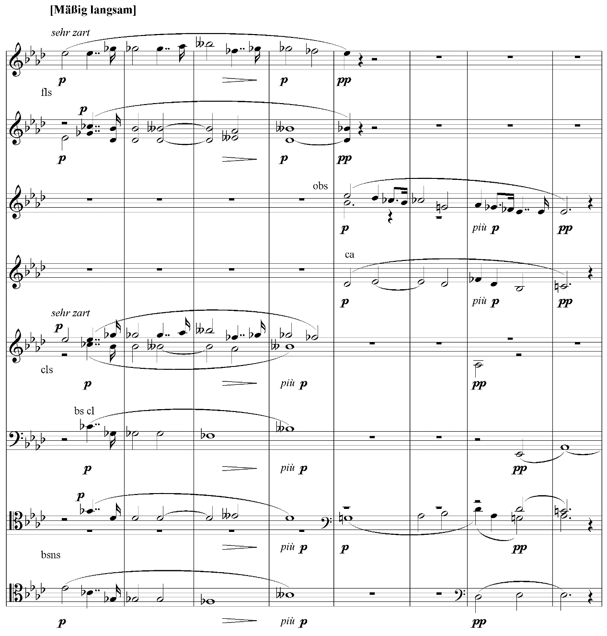
Example 1: Wagner, Lohengrin, Act 1, Scene 2, bb.9-16

It is Adorno’s contention, in fact, that Wagner represents both a significant advance in technical means and a simultaneous capitulation to ideology. The reification of Wagner’s music-dramas, the inauthentic presentation of the Subject/Object dialectic in society and its products through static and illusorily seamless relationships within his works, constitutes both regressive qualities and aspects of their ‘truth content’.
I will not explore Adorno’s conception of timbre and its role more generally within artworks as ‘cognition without concepts’ further here. It is worth remarking, though, that my conclusions where Jeux is concerned are precariously closer to Hegel’s Logic (which ontology can only emerge at the end of History, at least where the revelation of Being is concerned) than to the historical dialectic of revealed Being (i.e. its human historicality as forms of consciousness) with which the Phenomenology predominantly occupies itself.
The general historical emphasis on Hegel’s Phenomenology over his Logic is perhaps best exemplified, beyond Adorno himself (albeit to a qualified extent), by Alexandre Kojève’s extraordinary influence over French intellectual life through the twentieth century (in the work of Bataille, Lacan, Sartre et al.). Kojève’s readings, indeed, are very much consistent with Peter Hallward’s claim that Hegel simply ‘annexed philosophy to the mediations of History and the State.’ Historically, at least, the materialist implications of the logics of social change through contradiction have been very much foregrounded over the totalising Idealism into which the Logic all-too-readily lapses (where the logic of ‘scission’ is displaced by the circularity of becoming which, as the Absolute Idea, is always-already Being).
Aspects of the Logic’s rational ontology, though, can nonetheless be preserved, without aspiring to an Hegelian Absolute, against the successive ‘spirits of the age’ or ‘states of consciousness’ characteristic of the Phenomenology. As Bruno Bosteels wryly notes, the ‘question, then, is not whether Hegel should be revived at all but which Hegel. Or else, but this question is no doubt related to the first: which of his shoes should we try to fit, the left one or the right one? The one from the Science of Logic or the one from the Phenomenology of Spirit?’ [… Perhaps] we should say that both of Hegel’s shoes, like Van Gogh’s ill-fated peasant boots, are left ones and that the painful task ahead of us is to put them on at the same time.’ It is in this spirit, then, that I seek to assess Jeux with respect to its orchestration and its ontology since, as I will seek to demonstrate, aspects of the Logic prove remarkably insightful in this regard.

The Substance of Jeux
That timbre might be part of Jeux’s constitutive content, less accident than essence, is endorsed by Mark DeVoto who, following Jean Barraqué’s thoughts on La mer, remarks that its ‘compositional and orchestrational processes are completely unified.’ Strauss had argued that Berlioz was the first to have ‘consistently designed his works from the soul of the orchestral instruments’, and it is perfectly conceivable that timbre might indeed influence the compositional process in many 19th-century works. It would be unwise, however, to overstate the formative role of timbre in the case of Debussy and Jeux. On this point, Debussy wrote ‘I’ve finished Jeux [...] I’ll have to find an orchestra without feet for this music. Don’t think I mean an orchestra comprised exclusively of legless cripples! No! I’m thinking of that orchestral colour that seems to be illuminated from behind and of which there are such marvellous examples in Parsifal! I will turn to the nature of this orchestration presently, but the notion that something significant about the orchestral content had yet to be ‘found’ at this stage, despite Jeux apparently being finished, raises questions. Is it feasible that compositional and orchestrational processes can be completely unified if an indefinite proportion and stylistic quality of the work’s orchestration appears to have been conceived subsequent to the other parameters?
According to Robert Orledge’s revised chronology, the earliest known draft was made between 23 August and 2 September 1912. Here, ‘there are very few clues as to the instrumentation (and those that are there do not necessarily tally with the orchestral score […])’, but importantly, the draft does reveal that ‘Jeux was clearly conceived in orchestral terms as a polyrhythmic score.’ There are, though, ‘few dynamic indications, only one tempo marking (Più lento at bar 168), no sign of a constant quaver pulse, and (apart from the start) no indication that the percussion were to play an important role.’ That the piece in its initial form was conceived for orchestra, mostly on four staves, but with much of the instrumental detail to be determined (Orledge elsewhere refers to the ‘pre-orchestral stage’ of composition), is neither in itself particularly distinctive nor suggestive of orchestrational and compositional unification. Indeed, in her study of Jeux’s formative stages, Myriam Chimènes concludes that Debussy ‘viewed timbre as no more than a supplementary element, of decorative function, added at a later stage’ (what she also refers to as ‘orchestration-vêtement’). She does nonetheless concede that the préparation orchestrale (an interim stage between the particelle and the full score) ‘should in fact be considered a second germ of the work [after the particelle], in the sense that it contains the major part of the creativity regarding timbre.’ DeVoto’s claim is more immediately compelling as regards the work in its definitive state. In referring to Eimert’s famous remarks concerning Jeux’s organic inexactness of vegetation (‘the themes of Jeux are made up wholly of antecedents’), he observes that there ‘are very few motives of obvious structural importance’. Orledge counts twenty-one motifs which in their mosaic combinations ‘cover virtually every rhythmic permutation within a two-bar unit’, whilst Jann Pasler, in her significant 1982 study, identifies four ideas of particular significance. She draws particular attention here to Barraqué’s expression “mutation poétique” to describe Debussy’s ‘constant transformation of these tiny motives, the “thèmes-objets” which do not develop but recur, divide, and recombine in ever new ways.’ These thèmes-objets are presented in Examples 2 & 3.
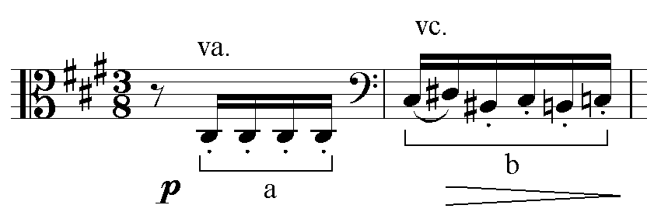

Example 2: Debussy, Jeux R1
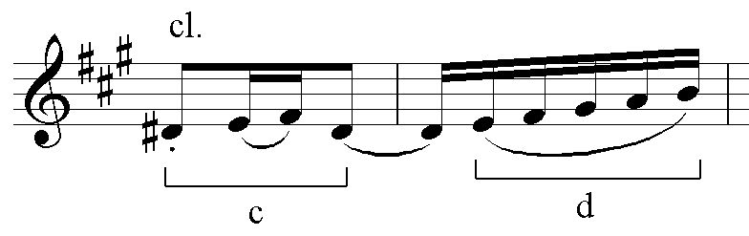

Example 3: Debussy, Jeux R6²

This fixation with the continual permutation of minimal material (‘a different motive for each section … its quantitative aspects fixed – that is, its metric, melodic, and even harmonic shape’) generally precludes expansion into broad melodic outlines. Pasler argues that this repetition does not ‘serve to construct a melody or fill a formal scheme; instead it directs the listener’s attention to the different instrumental and temporal contexts in which the motive appears. Because the motives in Jeux are short, usually two measures in length or built of two one-measure elements, Debussy uses them to shift interest from the level of melody to the movement of larger segments of the music’. Pasler goes on to describe how

each section of Jeux has its own unique quality, a characteristic motive, palette of instrumental color, and rhythmic signature. Repetition of one idea dominates each section, endowing it with its own distinct sense of time and giving rise to an expectation that it could continue indefinitely. Contrast and variety are secondary concerns within sections […] rhythmic and timbral contrast between sections [however] characterizes all of Jeux. Similarity or continuity with immediately surrounding sections is secondary to the surprise effect of metamorphosis.

Interestingly, she even suggests that the structural inter-relation between these sections, seen from a suitably hypermensural perspective, constitutes a sort of arabesque in itself.
The structural significance of this boundless quivering and its rhythm cannot, of course, be divorced from the ballet scenario to which it corresponds, though supposed cinematographic attributes may well be overstated. Indeed, Rebecca Leydon goes so far as to argue that the ‘enigmatic transitions [… and] disjunctive reiterations and duplications’ of Debussy’s late style may be seen to be modelled on ‘cinematic editing techniques that are contemporaneous with this music.’ And in particular, Jeux’s ‘qualities of formal discontinuity and its disorienting, over-abundance of motivic material’ correspond to ‘precisely the kinds of narrative modes that became possible and credible in the age of cinema’. Be this as it may, at the very least, as Pasler suggests, the scenario of a tennis game seems to have allowed Debussy to experiment with time and form, the volleys of a tennis game coupled with the characters’ varying relationships inspiring a form in constant flux.
Turning to the score itself, a seemingly representative passage, at least from the initial stages of the work (consisting of the stage-setting, and the introduction of the characters/scenario – before R27), is to be found between R6 and R10. Glancing at the piano version, which cannot of course be taken as wholly representative of the orchestral score but which is at least indicative, the material with which Debussy is working is certainly unprepossessing. At 3/1/3-4 motives c and d, identified above (Example 3), are presented, their momentum being immediately interrupted by a falling octave. Subsequently, from 3/2/1, variants of motives b and d (see Examples 2 & 3) combine in various forms until ‘une balle de tennis tombe sur la scène’. It is evident, certainly, that the motivic content of this section is somewhat restricted and repetitious. The phrase structure, too, hardly fosters a sense of melodic fluency or continuity; two four-bar segments give way to three two-bar segments, which then pass over into seven one-bar segments. It may at least be noted, though, that this fragmentation allows for a sense of goal-orientatedness that thus articulates the phrase’s culmination. Harmonically, little by way of traditional formal articulation is apparent, further emphasising this mosaic inertia. An initial orientation around a static C sharp (which Laurence Berman describes as more ‘important for [Jeux’s] tonal organisation than the A’, the work’s ostensible tonic) leads to ambiguous thirds allied to disorientating chromaticism generally from 3/3/1. The thirds might conceivably be understood as outlining a fragmentary V chord in C sharp minor, which then resolves onto I (Example 4). Not only, however, is the spelling in the right hand inconsistent with this analysis, but the subsequent bass A (3/4/4) suggests the A major orientation of the key signature.

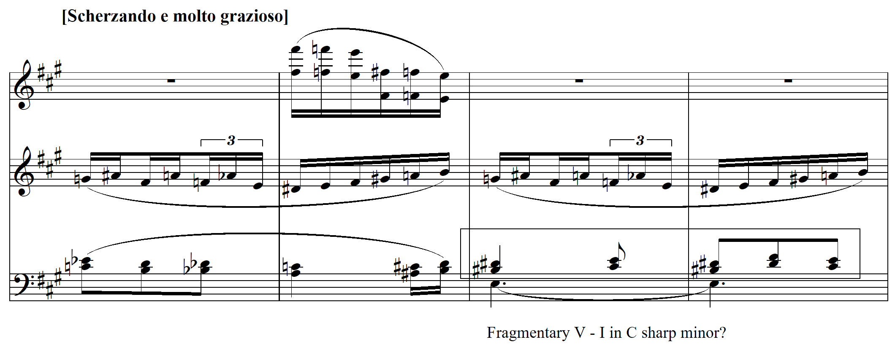

Example 4: Debussy, Jeux (piano) 3/3/3

This sense of suspended, or at least unorthodox, tonal motion is further emphasised come the end of the section, where Debussy lurches, without the slightest preparation, to a string of chromatically descending dominant seventh chords, tracing a motion from C dominant seventh to C with added sixth three bars later (Example 5).

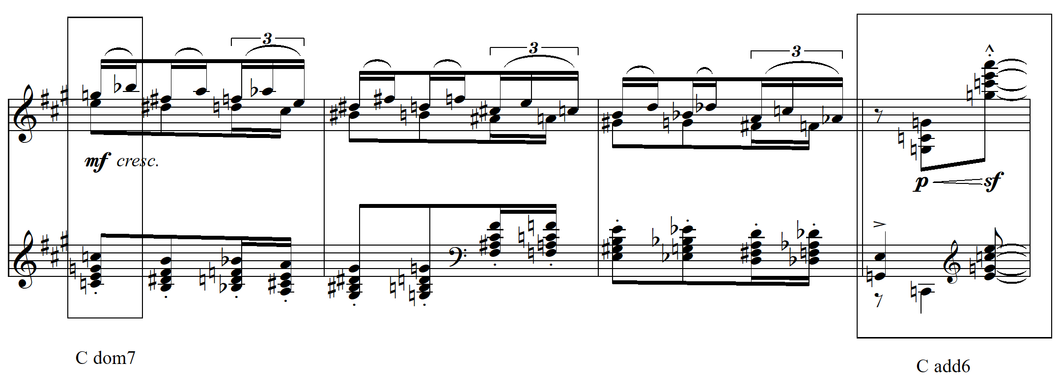

Example 5: Debussy, Jeux (piano) 4/1/3

At the very least this material might be described as self-effacing. Indeed, so much here is vague and lacking definition that a sense of flux is inevitable, for better or for worse. Amongst the contentions discussed above, however, was the promotion under these circumstances of timbre as a primary focus of attention. Since little by way of melodic continuity or harmonic trajectory is likely to maintain interest, the entries of various instruments and the decorative patterns of which their contributions consist become substantive in themselves. As such, the texture appears to consist of an intermingling of arabesques (Example 6).

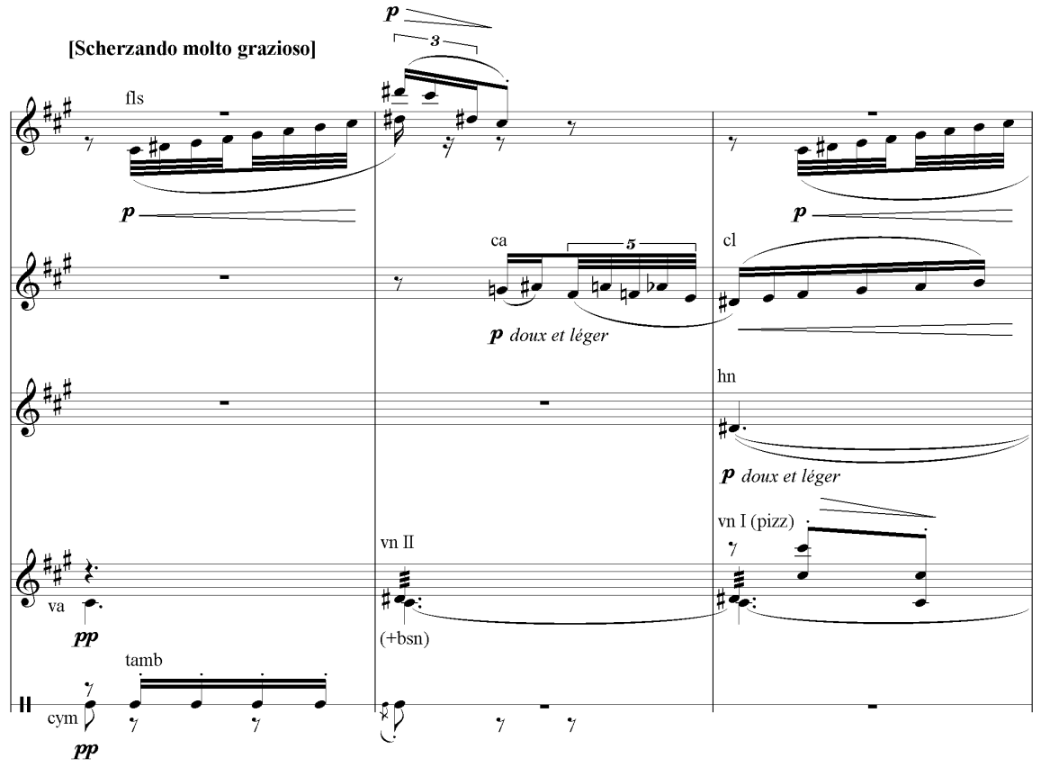

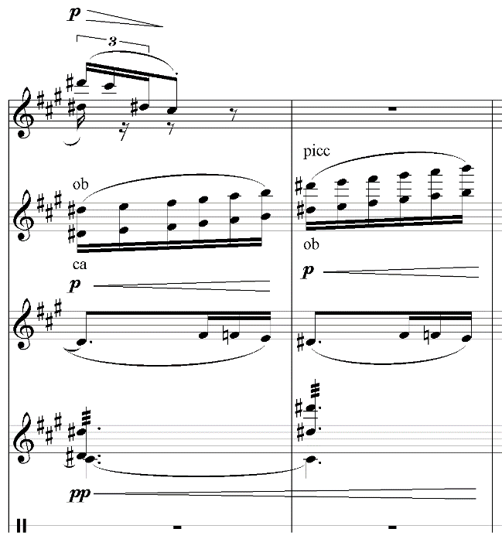

Example 6: Debussy, Jeux R⁵7

The above differs in respect of various details to the piano score, certainly, but the proliferation of detail in fact serves to render the melodic content even more indistinct. The percussion rhythm is familiar as motive a (see Example 2), and the appearances of b, c, and d coincide with the piano score, but the flute arches, additional falling octaves in the first violins, and various ‘backlighting’ effects, coupled with the constant permutation of timbre, create a luminous as much as linear effect.
Moving on to the second example from the piano score above (Example 5) as realised for orchestra, once again the sheer inconspicuousness of the material, seemingly so inconsequential from a wider perspective, recedes from view and in doing so foregrounds tantalisingly filigree textural features (Example 7).

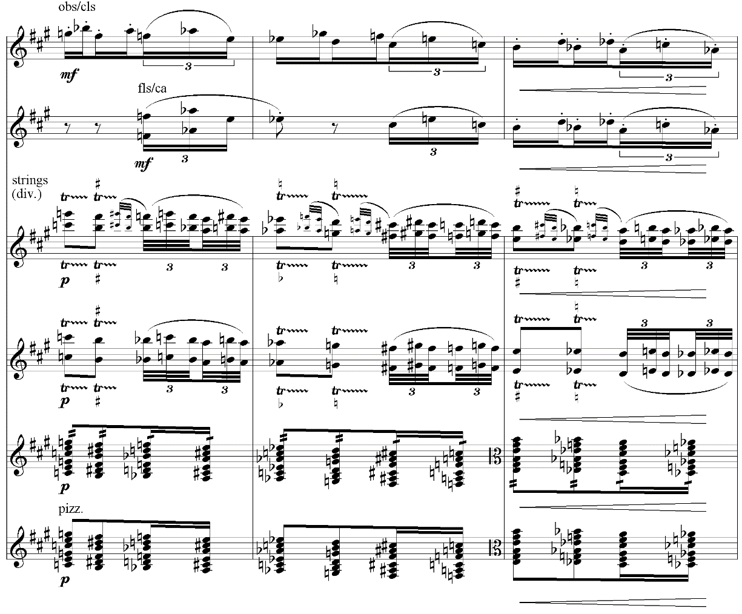

Example 7: Debussy, Jeux R8

The heterophonic nature of the above is familiar from much of Debussy’s orchestral music (examples abound, but Sirènes from the Trois nocturnes, all three movements of La mer, and much of Pelléas et Mélisande – particularly scene 3 of both acts II and III – are exemplary in this respect). Here, the woodwinds typically present the ‘melodic’ content, whilst the strings obscure the passage’s outlines through trills, grace notes, tremolo bowing, and pizzicato variants - particularly subtle is the combination in the strings of trills that culminate with ornaments and those that do not. The general effect is beguiling, and of far more consequence than the rudimentary melodic/harmonic content. DeVoto likens this propensity for decoration for its own sake to the ‘style of Couperin’s harpsichord pieces […] transferred to all divisions of the orchestra and greatly accelerated in tempo, like a speeded-up film, with much blurring of the musical surface.’
The passage that follows the tennis ball’s arrival on the scene (marking the young man’s first appearance) is so fragmentary that it barely registers as part of the work’s ‘substance’. It gives the appearance of being little more than a connective, in any case, but under such ephemeral circumstances it only adds to the ongoing sense of transience and fluctuation. Embellished by flourishes, the melodic aspect is limited to the ornament (transposed) with which the initial scherzando section began (Example 8) and a descending fragment (Example 9):
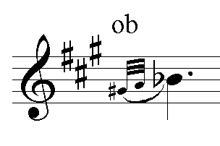

Example 8: Debussy, Jeux R⁴9

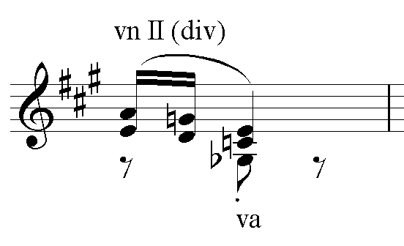

Example 9: Debussy, Jeux R³9
Following these slightest of entries, a heterophonic blend of wind and strings prepares for the ensuing section (Example 10). The harmony, as ever, is formally indeterminate, as (especially given the D from the preceding melodic fragment) it seems to relate to an acoustic scale built on C (though as it persists through the following phrase it gains a C sharp in the cellos).

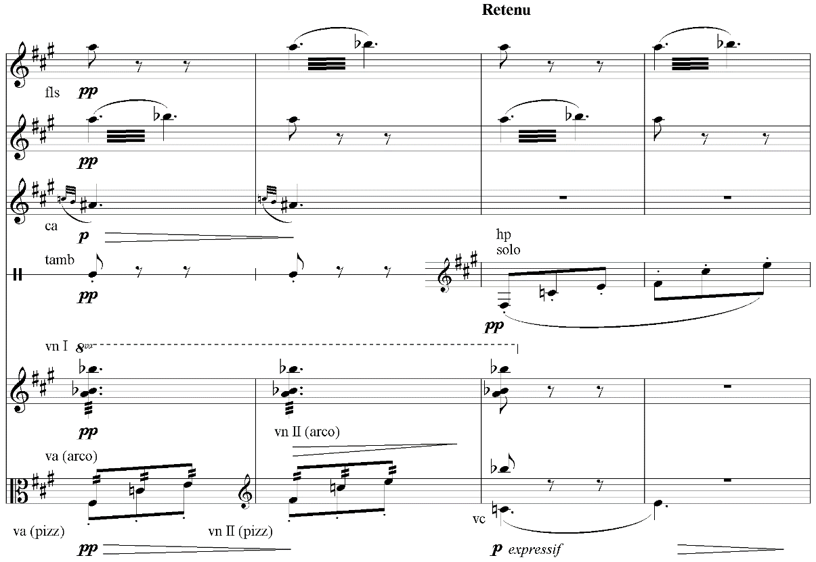

Example 10: Debussy, Jeux R9³

From a larger perspective, it is the contrast and frequent incongruity of adjacent sections that creates the sense of spontaneous morphology, of perpetual reconstitution so characteristic of Jeux. I would argue, however, that the rate of textural change coupled with the limited scope of the material, even within self-contained sections, emphasizes orchestral gestures qua gestures to a striking degree. It would be easy to overstate this case and thus it is worth remembering that Debussy resented the suggestion that he had abolished melody. Of what precisely, in Debussy’s mind, melody consisted, and how this melody constituted itself over larger expanses of music is certainly debatable; still, as Pasler remarks, Debussy ‘apparently wished us to remember his motives because of the many Jeux he plays with them throughout the entire piece.’
A further characteristic passage from Jeux’s early exchanges, R23 – 27 exemplifies rather more by way of discontinuity and disintegration. Again beginning with the piano score, the dotted figure at 12/3/4 is clearly drawn from the melodic features of the foregoing section, and thus the ensuing reduction to a bare tremolo is abrupt (if understated). This disjunction is then repeated, emphasising the misalignment, before drifting upwards in gestural fashion, in this case via a series of oscillating triads – the stage directions indicate that the young girls are disconcerted by the rustling of leaves at this point (Example 11).

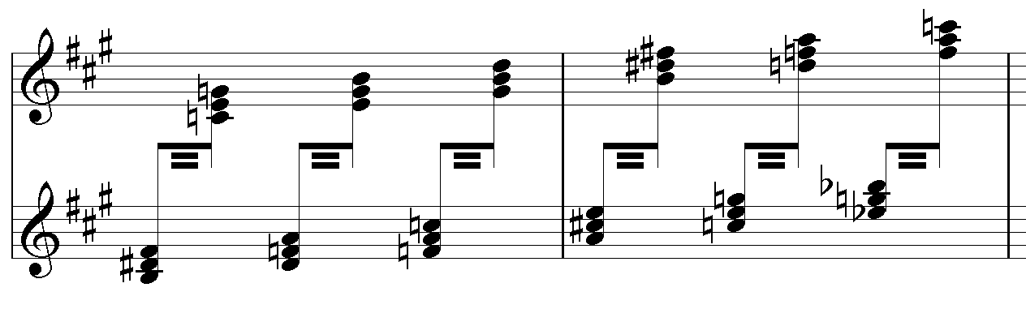
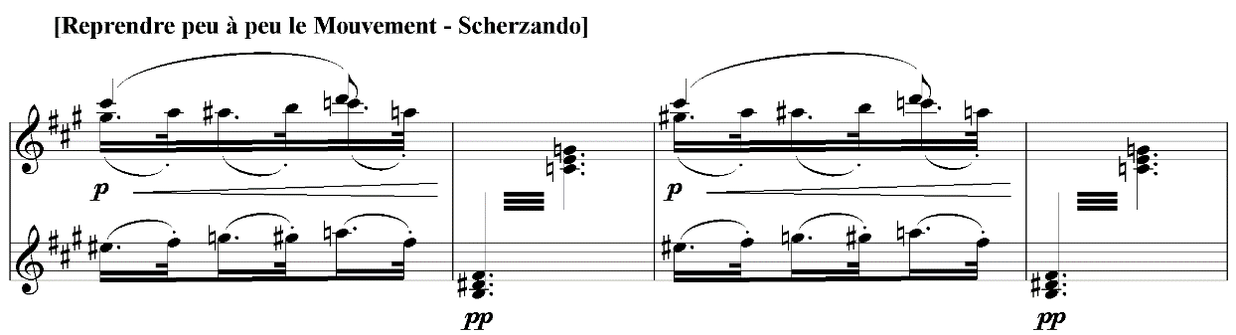

Example 11: Debussy, Jeux (piano) 12/3/4

A melody of sorts then emerges, but one of such limited scope that it seems constitutionally averse to continuity or expansion. Indeed, it quickly fragments before being displaced entirely – the young man here hides himself, following the girls’ movements (Example 12).

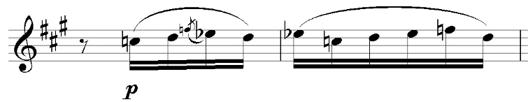

Example 12: Debussy, Jeux (piano) 13/1/1

This process of piecemeal abnegation intensifies at 13/2/3 where perhaps the most explicit gesture of the work thus far is made, the forte indication contrasting markedly with the previous piano. The textural clarity too, an almost declamatory homophony, is very much distinct from almost everything that has come before; this, too, then dissolves into low register, pianissimo murmurings (Example 13).
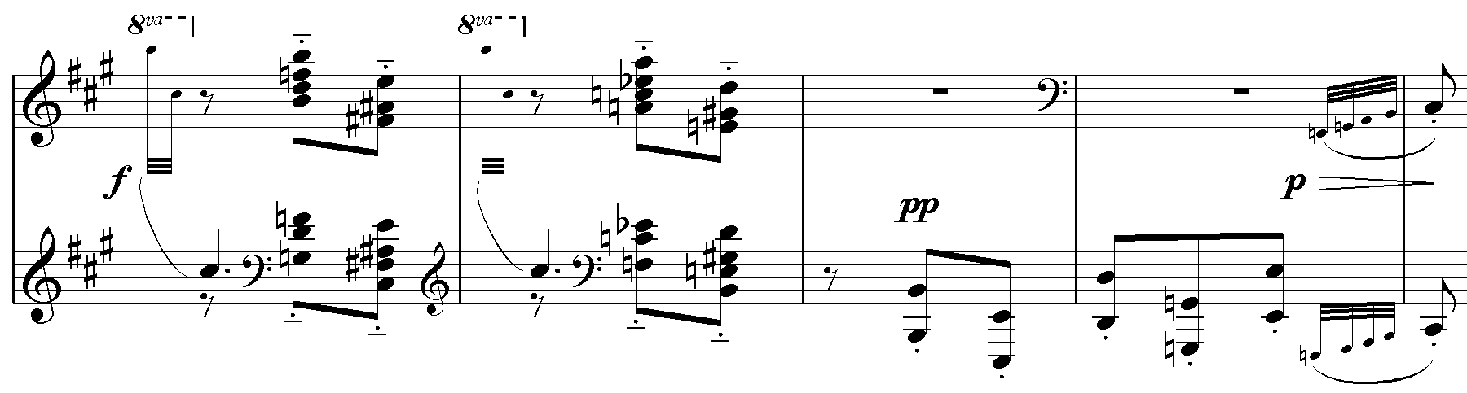

Example 13: Debussy, Jeux (piano) 13/2/3

The declamation is repeated in varied form, but the sense of fragmentation in fact only further intensifies from here. The C sharp (once again) that has begun to insinuate itself in the foregoing bars reasserts itself at 13/4/2, and this ‘radial pitch’ as a ‘guiding tonal force […] seems always to go hand in hand with a feeling of heightened anticipation, of breathless excitement.’ As such, it prepares the way (as quasi-dominant) for the F sharp major of the structurally significant section beginning at 14/4/3 and allows for the stability that the disintegrating texture would otherwise lack.
The rather cramped melodic idea discussed above, then, returns at 13/4/2 and is immediately succeeded by the return of the low register murmurings. This in turn displaces itself as a series of ornaments and flourishes, very much for their own sake (Example 14).

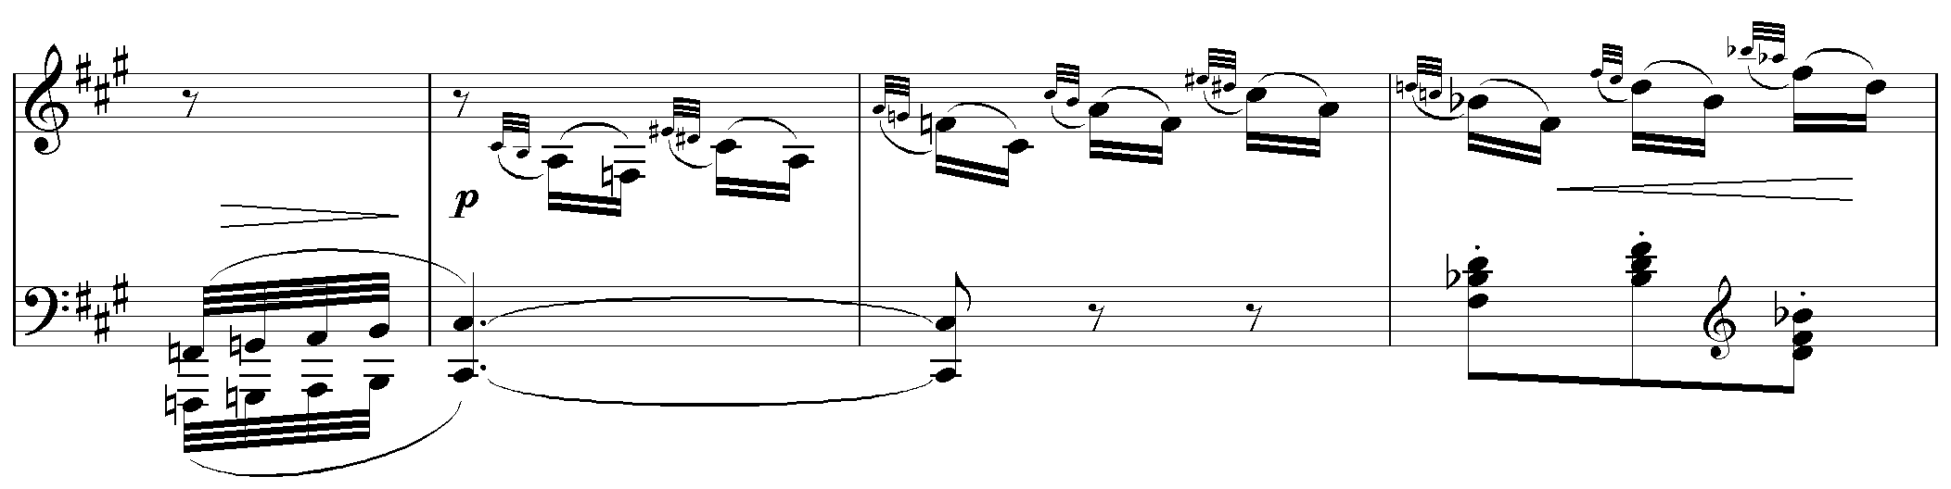
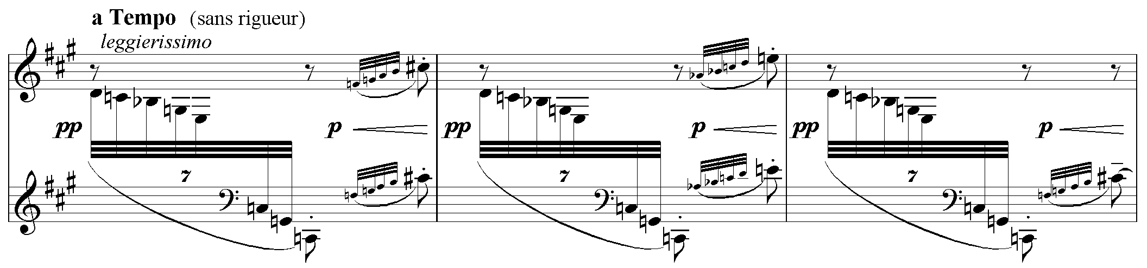

Example 14: Debussy, Jeux (piano) 14/1/2

The briefest of returns of the melodic fragment then dissipates into chromatic repetitions, leading to Jeux’s ostensible middle section (incongruously situated somewhat near the beginning).
Now, because of its surface inconsistency this passage should not perhaps be understood on precisely the same basis as those discussed above (Examples 2-5). It was the basic material’s seeming lack of interest on those occasions, indeed, or at least their innocuousness, that focused attention on Debussy’s decorative, protean orchestral patterns. This latter section, by contrast, is nothing if not eventful, and marked textural interest and variety is very much written-in, regardless of its orchestral realisation. The figure that begins at 12/4/3 in the piano version, for example, is presented in familiarly heterophonic orchestral guise at R23⁴ (Example 15).

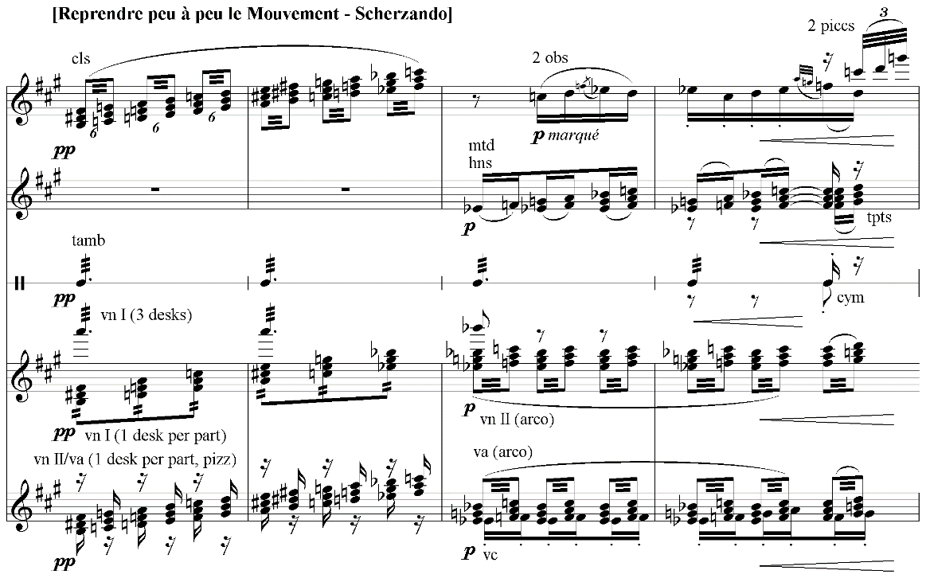

Example 15: Debussy, Jeux R23⁴

In this version, necessarily, attention is drawn to the tantalising orchestral details which become gestures sui generis; yet the idiom of the piano version is interesting and effective in itself, and the sense of abrupt juxtaposition with its surroundings is no less apparent. Certainly, the stridency of the chords and their subsequent disintegration from R24 (13/2/3) is equally as arresting in either case.
The particular resources of the orchestra are again in evidence at R¹26 (Example 16).

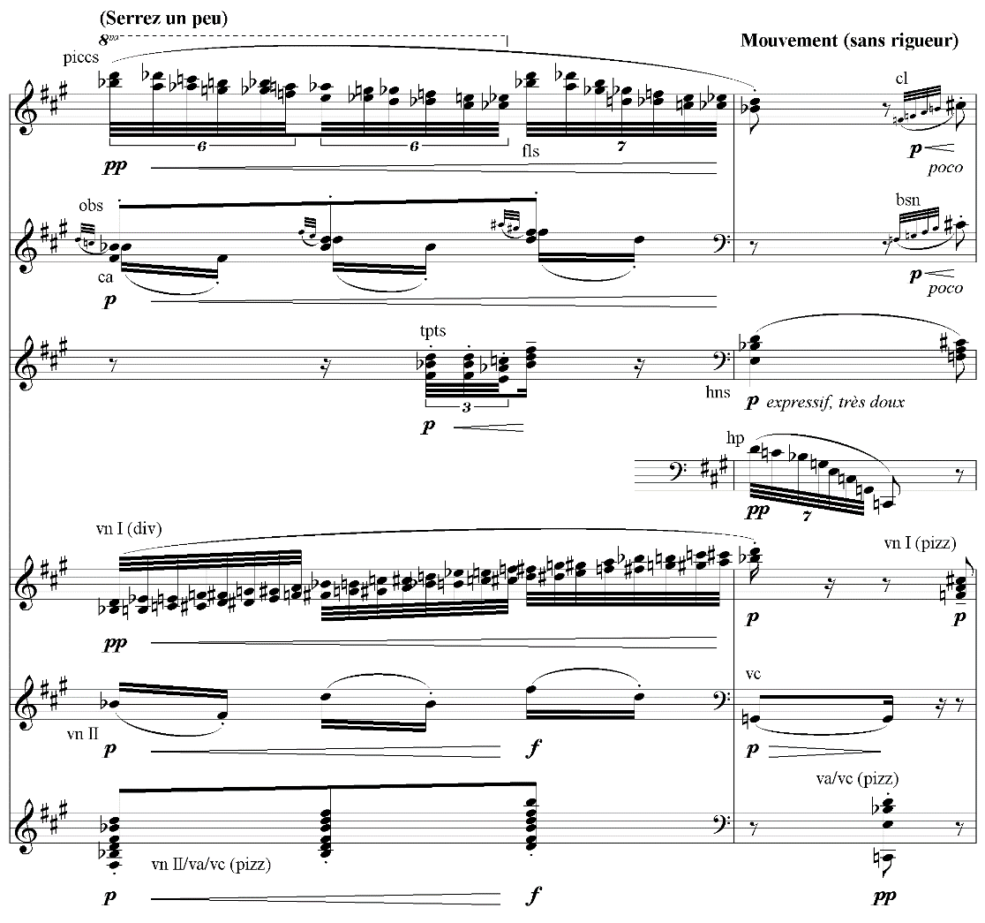

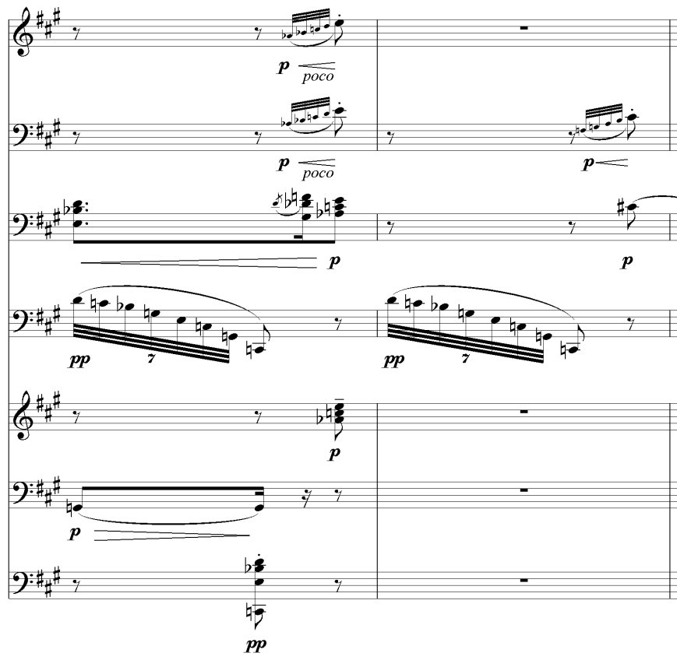

Example 16: Debussy, Jeux R¹26
The subtlety of the various combinations is absorbing, as ever, and Debussy’s predilection for infinitesimal gradations between pianissimo and piano is particularly evident here. The pianist Robert Schmitz recalled that crescendos ‘were one of Debussy’s obsessions in piano playing. He liked slight crescendos, a ppp increasing into a mere pp […] Another thing Debussy insisted upon was the proper way to strike a note at the piano.’ Both these attributes are very much applicable by extension to the orchestral Debussy, as the above example ably demonstrates, and the understated variety of articulations (particularly between staccato and tenuto) and dynamics is delicate in the extreme. When coupled with the array of flourishes (and their contrasting articulations), ornaments as against varying attacks, and graded decays (particularly cellos against horns in the second and third bars), the effect is avowedly, even primarily, orchestral. This hugely nuanced sophistication undoubtedly therefore appears constitutive as content proper, or becomes so, in the orchestral Jeux. In reality, though, it is the juxtapositions, fragmentations, and stark contrasts, allied to the markedly gestural nature of the figures themselves, which create this impression. These qualities are thus substantially inherent in the piece even at the ‘pre-orchestral stage’, and unlike the first section discussed, it is therefore an overabundance of interest rather than a lack of it on this occasion that emphasises the orchestra’s limitless resources and contrasts. As such, Jeux could potentially be arranged for all manner of instrumental media and exploit their capabilities equally effectively.
One further observation I might make in passing concerns the final bar of the above extract. Ravel was famously derisive in his attitude towards La mer’s orchestration, even claiming it to be so bad that, had he the time, he would re-orchestrate it; and DeVoto feels that passages such as bars 5-8 and 142-52 of Jeux de vagues were perhaps amongst those at fault in Ravel’s eyes. Indeed, many of the textures are of such a fleeting, quicksilver nature that delicacy is always in danger of slipping back into outright fragility or brittleness. Debussy’s desire to find an orchestra ‘without feet’ for Jeux similarly runs the gauntlet of lapses that might at best be described as tenuous.
Following what to this point has amounted to a preamble, the section that begins at R27 intensifies the mercurial qualities of the foregoing in accordance with the scenario; no longer merely a flexibly mutable surface feature, incompatibility here rigidifies into a determinate structural feature. On this basis, the protagonists are each ascribed metric and orchestrational characteristics, and the dancers’ interaction is faithfully realised through the interplay of these features. The young man’s metre, for example, is 3/4 in association with predominantly clear (often homophonic), melodic string writing (arco); the first young girl, by contrast, is represented by 3/8 and highly decorative wind writing, supported by hesitant bowed strings and rhythmic pizzicato; the second young girl’s musical identity enters a little later, at R33, and is light, staccato/percussive and predominantly consisting of melodic winds (2/4).
The young man’s tentative dance at R27, initiating his liaison with the first girl, lasts for two bars (Example 17).

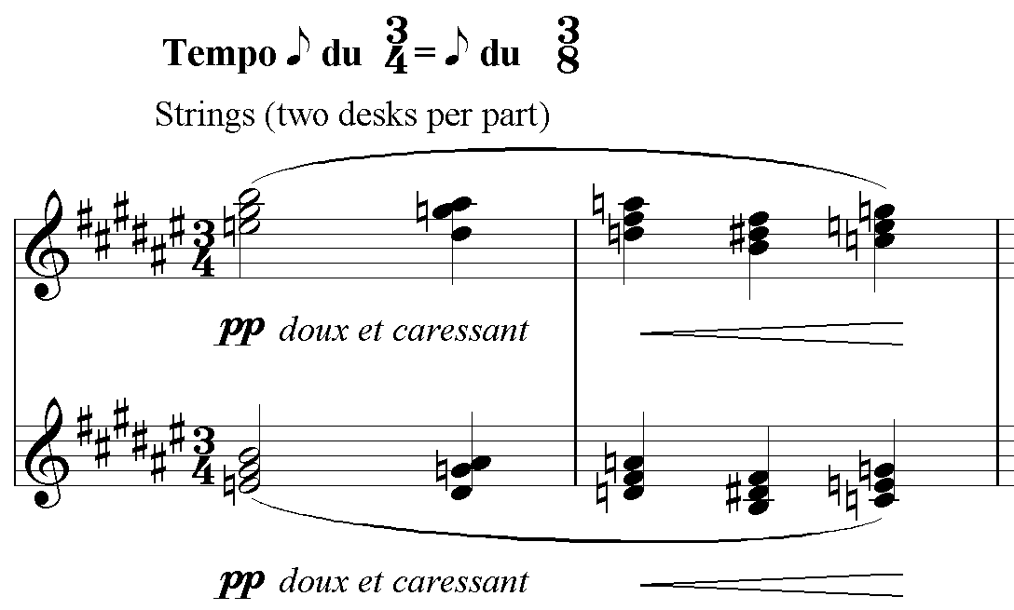
Example 17: Debussy, Jeux R27

Four bars of 3/8 denoting the first young girl’s anxious but excited response immediately displace this, the first two bars of which are given below (Example 18), before the young man’s string texture returns, now in 3/8 as his continuing attempts to persuade the girl to dance begin to reconcile the ‘conflict’. (The varied repetition of these three segments, from R29, is further decorated to particularly subtle orchestral effect.)

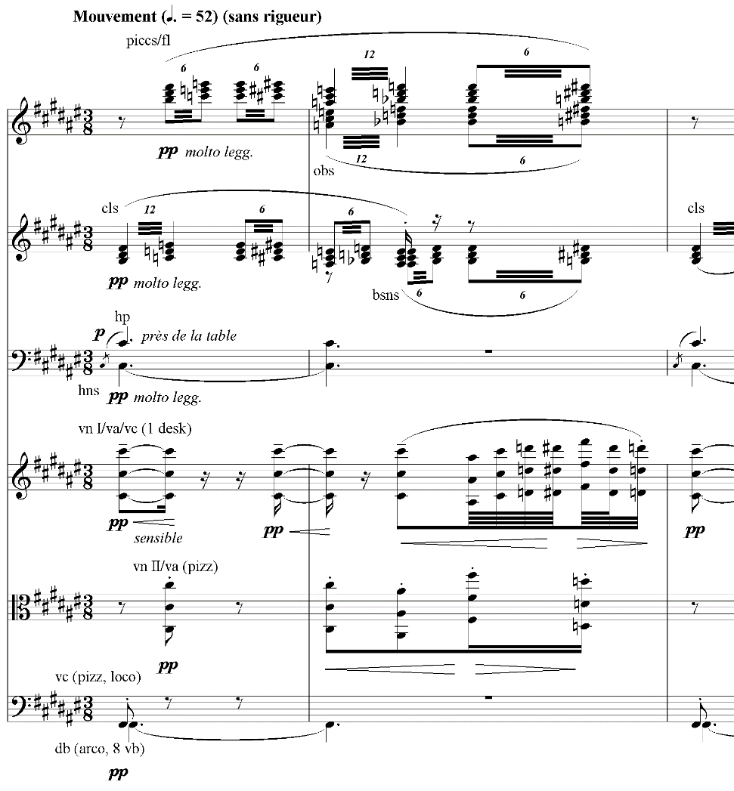

Example 18: Debussy, Jeux R27³

This process culminates at R32 as the two identities merge (marked passionnément), wind trills intermingling with homophonic, melodic strings in 3/8 (Example 19).

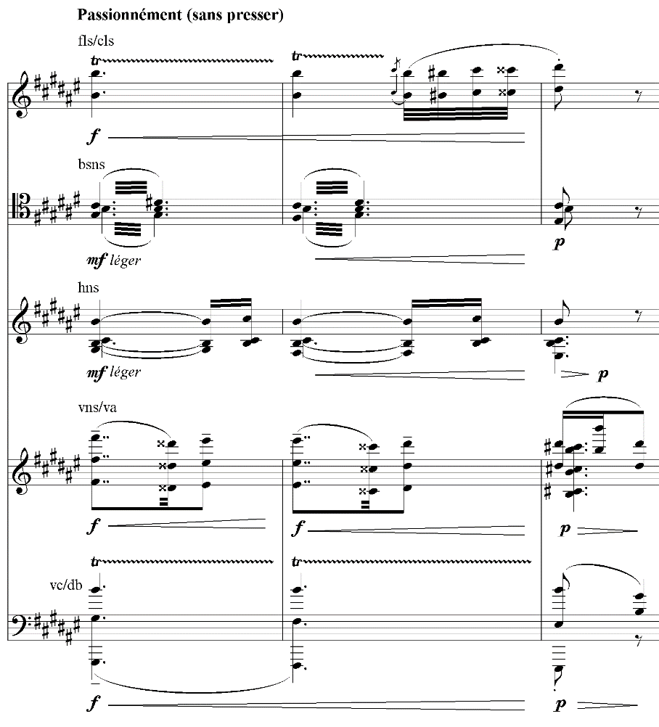

Example 19: Debussy, Jeux R32

Following this, R33 introduces the second young girl, interrupting the amorous exchanges of the dancing couple with a mockingly ironic dance. By design both light and clumsy, the bowed violins and mezzo-staccato horn (en cuivrant légèrment) assure discreet sonority beneath the more pointed articulations of the flutes/pizz. violins combination. The registral incongruence of the ever-comic bassoon and tin-whistle piccolo misaligning a chromatically vagrant figure, meanwhile, adds to the ungainly nature of the cluster harmony and plodding rhythm (Example 20).

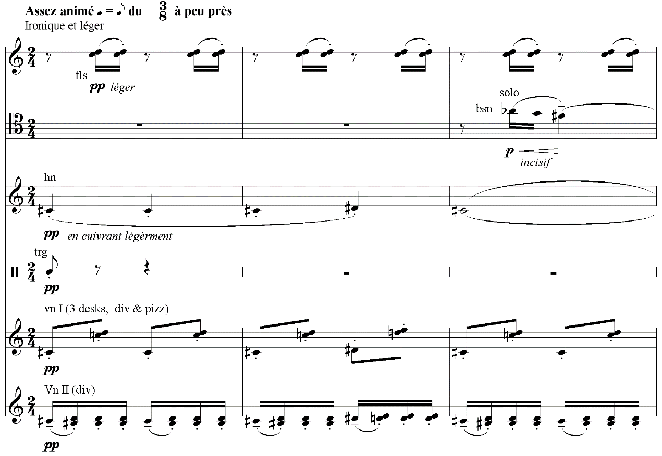
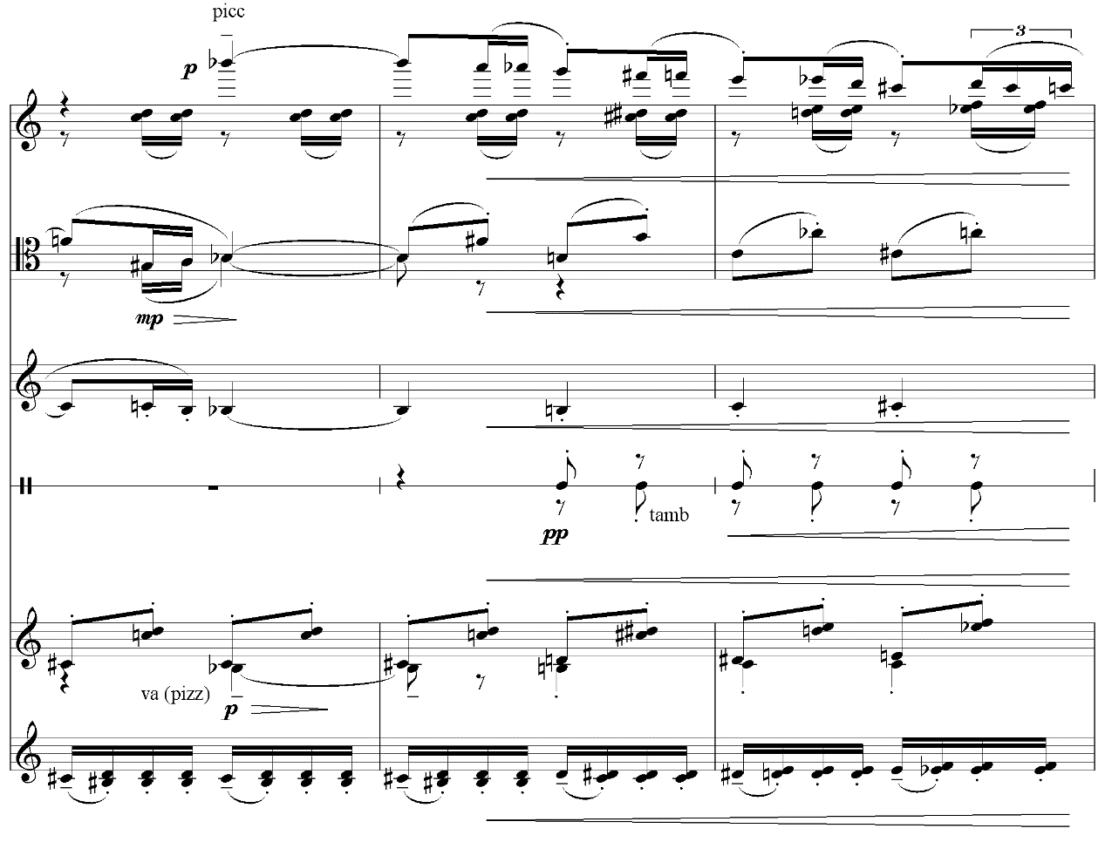

Example 20: Debussy, Jeux R33

It is not necessary here to chart each stage of this narrative (the juxtapositions and intersections of which continue to coincide with the details of the scenario in similar fashion until R51), but I would argue that the substantive nature of Jeux’s orchestral and metric aspects under these circumstances is manifest. Undoubtedly, the malleable qualities of the passages discussed earlier focused attention, perhaps to an unprecedented extent, on orchestral/gestural contrasts, but this section is strictly unthinkable on any other basis. As regards orchestration, it may well be argued that certain textural and metric constituents are written-in regardless of the instrumental medium (as was the case earlier). There, however, the textural comportment served to promote orchestrational interest in general, allowing for the subtleties of Debussy’s orchestration to become a primary object of interest. Here, the semiotic aspects of the instrumentation (allied to metric and textural features) cannot be written out (i.e. removed).
It is evident, in any case, that the piano version is inadequate at this point, especially where complex textures arise from the convergence of disparate ideas. Pages 17 and 18 (leading to the passionnément section) amply demonstrate the significance of details that cannot actually be played by the pianist, included as they are above and below the piano’s staves. Even were these details practicable, a significant discontinuity would here emerge between the piano and orchestra versions, specific timbres now being ineradicably associated with the narrative in the latter. Since these timbres are now in themselves meaningful, they necessarily constitute compositional events (which is to say, they are part of the work’s content) where they are introduced, events that are missing in the piano version. As such, timbre is a constitutive part (or dimension) of the orchestral Jeux (in this part of the work, at least), regardless of the relation of the two ‘versions’.
From R51 the dynamic of the ballet changes again with the resumption of a constant (if increasingly nominal) 3/8 time signature. Interestingly, from this point until the fortissimo climax at R78, there are virtually no stage directions (all of which are only to be found in the piano score) aside from an initial ‘Let them look around themselves: the beauty of the night, the joy of the light, everything encourages them to give free rein to their fancy.’ As the characters begin to follow their fantasy (leading to the pas de trois at R61 and culminating in the triple kiss at R78), Pasler rightly observes that the music becomes ‘the central drama[, which thus] create[s] a more powerful scenario and translate[s] what is happening within the three characters on stage more appropriately than if Debussy had attempted to create a musical replica of the dancers’ exact movements.’ This is achieved predominantly by polyrhythmic means, initially through the juxtaposition of triple- and duple-time figures and ultimately through the superimposition of 3/8, 2/4, and 3/4. To begin with, some measure of timbral contrast is still discernible, as at R53 (Example 21), where the strings (and bass clarinet) initially feature in 3/8 whilst the winds superimpose 3/4 across two bars (in three 2/8 instalments). The strings then introduce a 2/4 polyrhythm in the third bar (following which the horns reintroduce 3/8 at R⁴54).

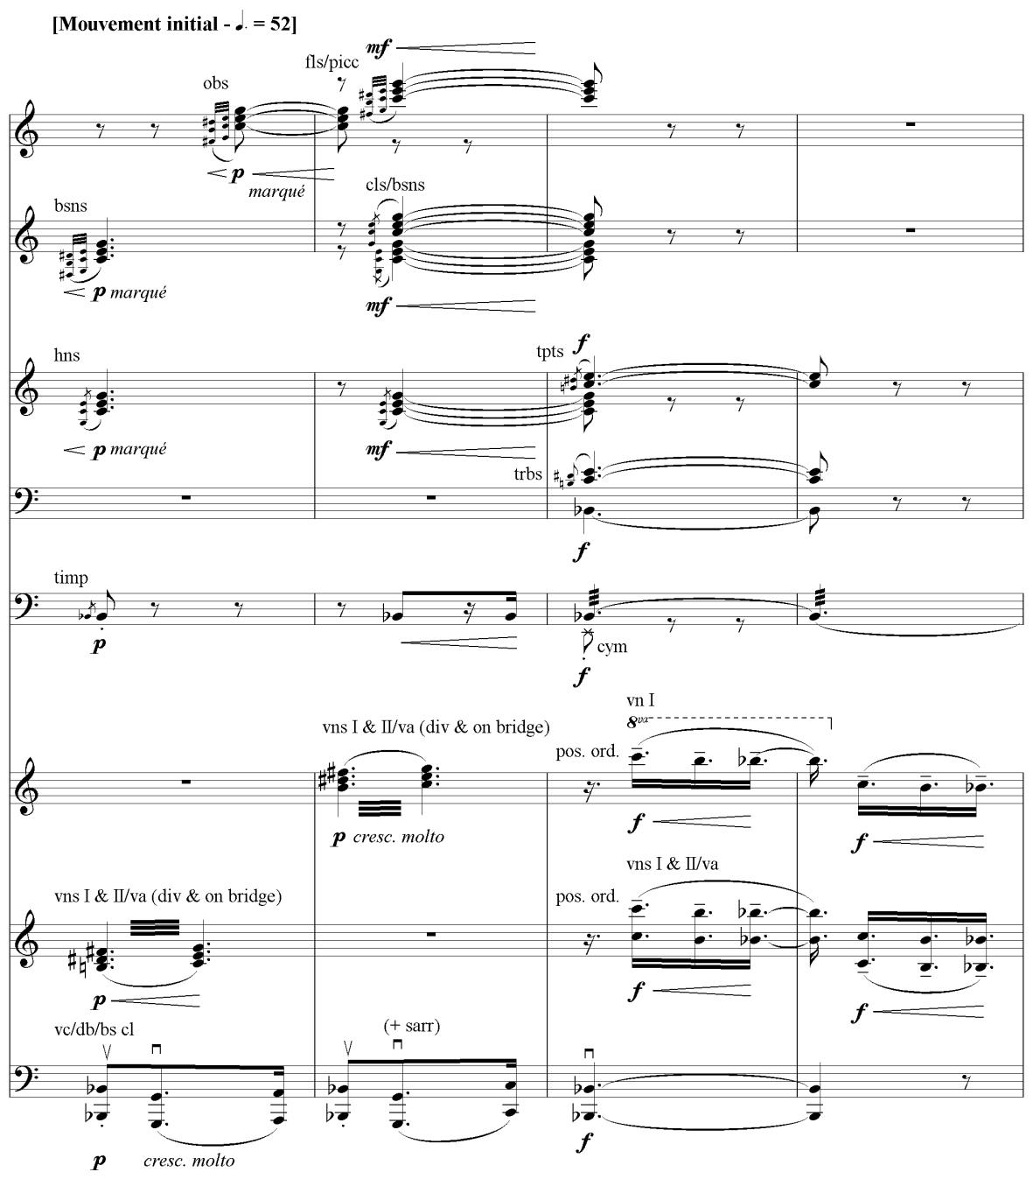

Example 21: Debussy, Jeux R53
This timbral identity is, however, increasingly obfuscated so as barely to register. There are exceptions, R64 being notable for its clear melodic strings in duple time as against wind trills in triple time, but rhythmic disjunction is very much the driving impulse towards the piece’s climax. As such, timbre here retains compositional interest in its characteristic fluctuations, but its significative import is somewhat reduced. Indeed, the timbral tide goes out even further at R³65 where an emphatic and extended melody emerges; and this overtly melodic/harmonic orientation obtains still more obtrusively, following a series of dominant preparations and dominants in D flat major, at R66 where the harmonic trajectory is unmistakeably B major (Example 22).

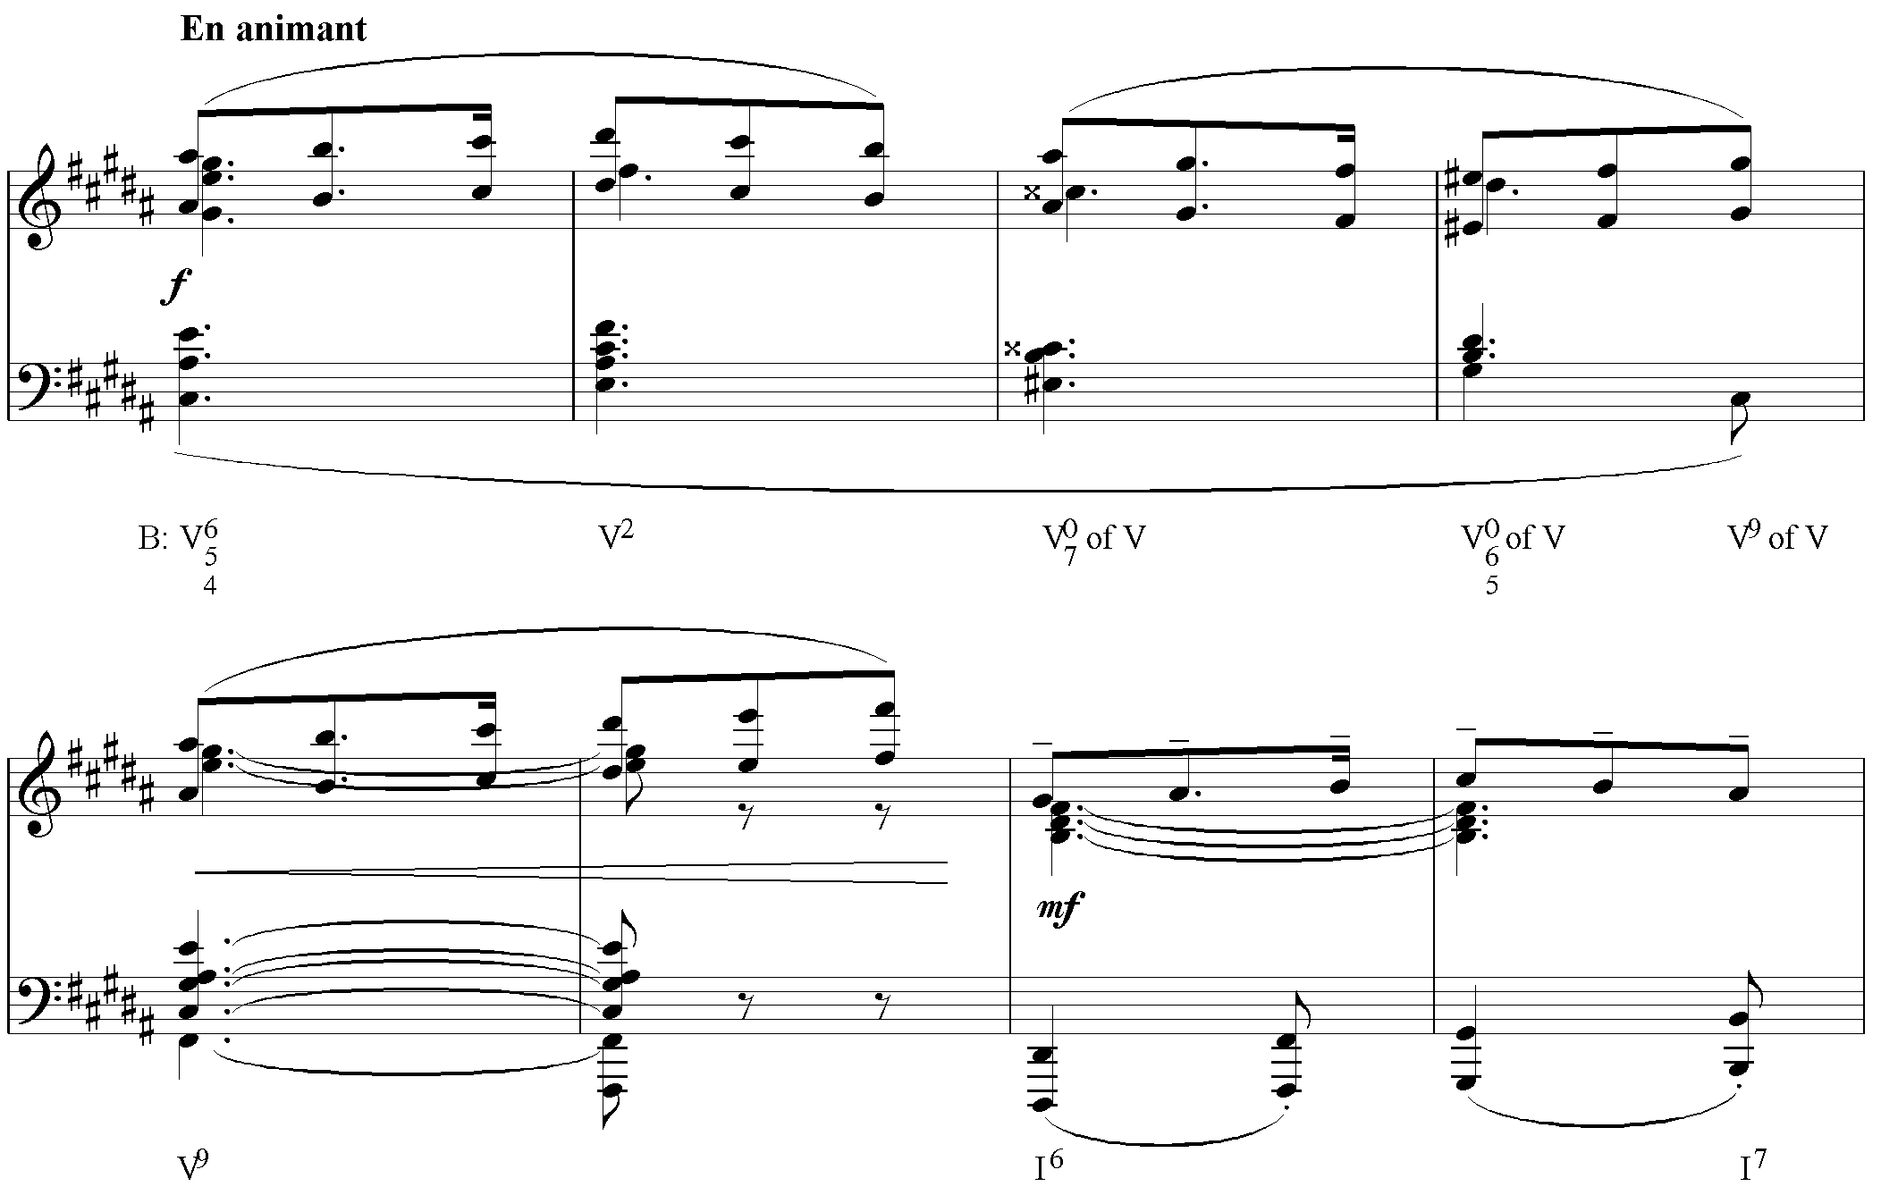
Example 22: Debussy, Jeux R66

To be sure, the arrival at the tonic is obscured by suggestions of submediant harmony, but the tonal implications are unmistakable here and in the subsequent bars. Now, much that has been discussed to this point, regarding the effacement of traditionally constitutive musical parameters (principally tonal melody and harmony) and the consequent promotion of ‘secondary’ elements (timbre, texture, and rhythm), ceases to obtain under these circumstances. However alluring the orchestral setting (and its textural refinement certainly bears comparison with much that has come before), the melodic/harmonic context is neither indifferent, inconsequential, nor so inherently filigree as to dissolve into a continuum of contrasting orchestral gestures (or arabesques). As such, it is difficult to see how these passages differ markedly from much orchestral music in a constitutive sense – the form/content can barely be described as determined or articulated by timbre, texture, and rhythm (beyond local implications of harmonic rhythm) to any unusual extent. Whatever these local implications, however, the larger-scale metric relationships, the unifying quaver pulse underpinning the whole, and the dazzling, dizzying contrasts between sections (an arabesque in its own right), are hardly negated by the more traditional orientation of these particular events.
By R⁴71, the process of polymetric (dis-)integration begins to culminate, in advance of the dynamically emphatic violent sections, with the simultaneous rendering of 3/8 (predominantly in the winds and first harp), 2/4 (trumpet and second harp), and 3/4 (violins and first horn) – a further, if inconsistent, instance of timbral division (Example 23). (Interestingly, this metric multiplicity had long been anticipated, notably as a characteristic of the initial girls’ dances and in anticipation thereof from around R16.)

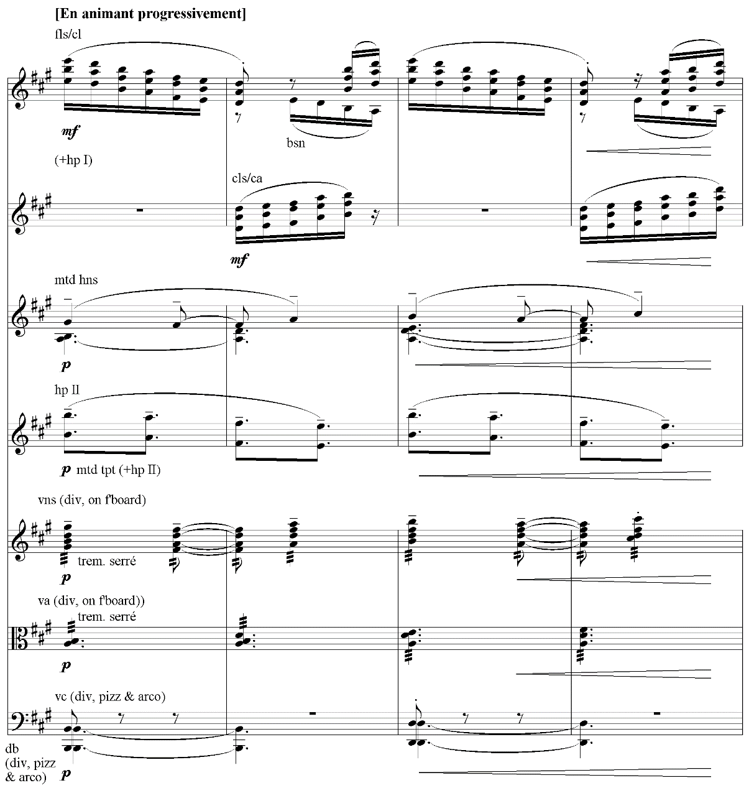

Example 23: Debussy, Jeux R⁴71

The triple kiss then finally ensues at R78 (Example 24) with the long-awaited fortissimo (never explicitly indicated before this point) and a final gesture of metrical mediation, the 3/8 motive c augmented to become a 3/4 figure (within a noticeably homophonic textural context).

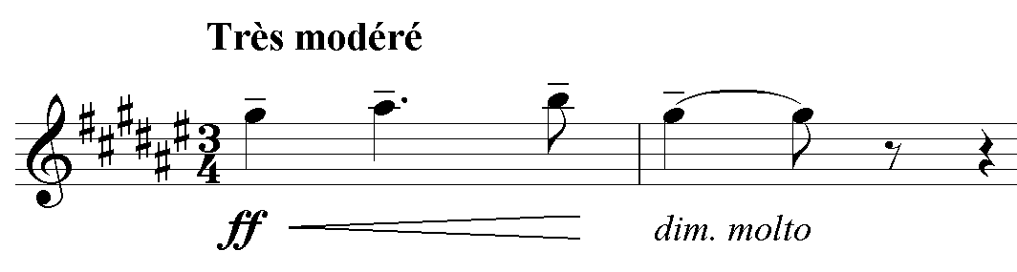

Example 24: Debussy, Jeux R78

The end follows swiftly as a tennis ball falls at the dancers’ feet, startling them into dispersing into the night. Berman considers it ‘typical of Debussy’s later compositional practices that a single gesture followed by a short aftermath should be responsible for resolving a significant development. This is in keeping with his avoidance of heroic statement – his preference for the effect of paroxysm or the blinding flash of clarity.’ Thus, the final twenty-one bars (from R80) are fragmentary in the extreme and symmetrically reverse the work’s opening – two 3/8 sections are interrupted by a passage in 4/4, the bass line discreetly tracing motion from A to B to A. This last detail, interestingly, is by no means apparent in the piano score.

The Necessity of Contingency
All the above, then, demands that DeVoto’s contention concerning the unification of compositional and orchestrational processes be revisited. It is evident, certainly, that the two undertakings were not simultaneous, but this does not itself necessarily preclude their being understood as a unity. That this understanding cannot be extended equally to all sections of Jeux is clear enough too, though the predominance of orchestral gesture at various junctures may well appear convincing on this point (particularly, amongst those discussed, the passages beginning at R6, 23, and 27). What remains difficult, however, is that the two processes be conceived as unified in any conventional sense. It would take a rather particular interpretation of ‘processes’ here for it to be concluded that two courses of events fuse indissociably (the unfolding of the music and the orchestral features, once determined, in act); on this basis, it would be difficult to see how the performance of any orchestral music could fail to unify the two. Indeed, ‘compositional and orchestrational processes’ suggests the activities of composition and orchestration in any case. This is therefore surely better understood not as unification but as synthesis since the two processes serve to mediate one another.
At first sight this distinction may well appear pedantic, but, as suggested in several of the examples, an important distinction emerges. On the one hand, much of the ‘music’ (as melody and harmony) is self-effacing and at times unremarkable; it therefore promotes textural and timbral interest by design, a quality that in principle need not be limited to the orchestrational choices Debussy actually made. On the other, some sections are so inherently varied, texturally decorative, and subtly nuanced (as gestures) that this principle intensifies itself to the point where almost any ensemble could be exploited to interesting effect (the interest being ‘written-in’). As such, the material supplicates itself in advance to its medium, just as its medium is the empty potentiality of the material’s being realised. As poles of mediation they contain each other within themselves, and thus the process is dialectical – in recursively tripartite Hegelian fashion, the ‘in-itself’ (the material as implicit, potential, inner nature) of the particelle sublates as contradictory unity (Gegensatz) its relation to timbre so as to become explicit and posited i.e. a work (a moment) for piano solo. The culmination (Aufhebung) of this movement, however, Jeux ‘for-itself’, only arrives through the ‘préparation orchestrale’ at which point it becomes an entity in conformity to its nature.
Thus, texture and timbre here very much belong to Jeux’s substance where mutatis mutandis this is understood in Hegel’s sense, which is to say, ‘the totality of [its] accidents […] Substantiality is the absolute activity-of-form […] and every content is just a moment that belongs to this process alone [… Substance] without preceding dialectical mediation – being the universal might of negation – is only the dark, shapeless abyss, so to speak, in which all determinate content is swallowed up as radically null and void, and which produces nothing out of itself that has a positive subsistence of its own.' Given that it is within ‘Actuality’, as the third subsection within ‘The Doctrine of Essence’ that ‘Substance’ emerges in both versions of the Logic, what we are to understand here is that the externally real fully expresses the essence and that this is the case specifically on the basis of prior dialectical mediation. Were this not the case, Jeux and ‘its’ orchestration would remain forever external to one another.
Now, properly speaking, of course, this is to be grasped in accordance with the movement of comprehension as a whole and thus the Concept (Begriff) and its unity with fully comprehended concepts (Vorstellungen) – ‘since each of [the Concept’s] moments is the whole that it is, and is posited as inseparable unity with it, the Concept is totality; thus in its identity with itself it is what is in and for itself determinate’. Hegel elsewhere – in the Greater Logic – in fact defines substance as implicitly what the Concept is explicitly. Nevertheless, Hegel’s (putative) ontology of being as becoming, ultimately the movement of spirit, need not be overemphasised here (which is to say the identity of subject and object, or the cosmos as the full expression of fully realised and posited, unconditioned, self-conscious subjective rationality i.e. the Idea itself and its return to Geist). The dialectic whereby ‘essence’ and ‘unessence’ (modal categories) pass over into substance is at the very least indicative of how Jeux (or moments thereof) may be understood.
And on this basis, providing we are prepared to read Hegel’s Logic as simply an analogue of rationality, there is no need for us to be talked down from giddy metaphysical heights – to reiterate, the relative immediacy of the initial (implicit) instantiation of Jeux is this way mediated by the negating activity of orchestration, culminating in the overcoming of its ‘given-being’ in the actual (i.e. in accordance with its concept), realised and posited product. Indeed, this can be simplified further, even in ontological terms, in saying that the initial instantiation of Jeux is inadequate given certain criterial attributes known in advance (by Debussy, since the negating activity in question is his own, and latterly by us) and that this real contradiction is overcome in the full orchestral version. Contingency – here, whether and how Jeux might be orchestrated – proves to be necessary since Jeux’s inner nature is such that it must be realised if it is to be consistent with this nature.

Abstract: This article seeks to determine the extent to which timbral and textural concerns inform the musical substance of Debussy’s Jeux. Of particular interest are passages in which foreground detail effaces itself in the interests of orchestral qualities, those where an overabundance of surface detail is preconfigured so as to maximise orchestral efficacy, and sections where a more traditional distinction between compositional content and orchestrational attributes seems to obtain. It is Hegelian substance ultimately that I have in mind, however, on which basis I seek to distinguish between unification and synthesis – I argue that Jeux’s immediacy is overcome through negating (orchestrational) activity, arriving thus at the objectively real (realised and posited) product. On this basis, Jeux’s substance, including its orchestral aspects, is best understood speculatively.

Keywords: Debussy, Jeux, orchestration, substance, Hegel

Biography: Simon Clarke is a philosopher and musicologist whose specialisms range from Derrida and Badiou to metal via nineteenth century music. Active, in addition, as a composer and performer, his ensemble Vulgar Display attempts to fail to reconcile extreme metal and contemporary classical music.

‘[S]euls, les musiciens ont le privilège de capter toute la poésie de la nuit et du jour, de la terre et du ciel, d’en reconstituer l’atmosphère et d’en rythmer l’immense palpitation’. Debussy in a S.I.M. article of 1 November 1913, reproduced in Claude Debussy, Monsieur Croche et autres écrits, ed. François Lesure (Paris: Gallimard, 1971), 240; he derides ‘symphonic painters [peintres symphonistes]’ whose studies of Nature are ‘disagreeably artificial [désagréablement artificiel]’, whilst painters and sculptors can only give the universe in their own ‘somewhat free and ever fragmentary interpretation [interprétation assez libre et toujours fragmentaire]’. Ibid., 239-40. N.B. All translations are my own unless otherwise specified.
Peter Kivy, ‘Orchestrating Platonism’, The Fine Art of Repetition (Cambridge: Cambridge University Press, 1993), 75-94 at 78. For a conflicting account of timbre’s status here, see Jerrold Levinson, Music, Art, and Metaphysics: Essays in Philosophical Aesthetics (Oxford: Oxford University Press, 2011).
Cited by Manuel Rosenthal in conversation with Roger Nichols, quoted in Roger Nichols, Ravel Remembered, (London: Faber and Faber, 1987), 67-8.
Frederick Corder, ‘Instrumentation’, in: J. A. Fuller-Maitland (ed.), Grove’s Dictionary of Music and Musicians 2nd edition, 5 vols. (London: Macmillan, 1906), II, 473-84.
Dolan, The Orchestral Revolution, 256-7 – see chapter 6, ‘Abuses of the Orchestra’, for reflection on these orchestral polemics in depth.
I will distinguish on occasion between ‘timbre’ and ‘texture’, or ‘instrumentation’ and ‘texture’, although more usually I will simply refer to ‘orchestration’ and variants thereof to encompass both. The contrast should generally be understood as being between sounding materials, or embodied sounding qualities, and more abstract structural categories (e.g. polyphony, heterophony etc. – thus, a texture may remain the same, which is to say conceptually consistent, despite differing instrumentation). This is by no means without ambiguity, however, especially given that the problematic relation of materiality to abstraction is precisely what is at issue below, though in given contexts the apparent distinction should be borne in mind. Interestingly, Jonathan de Souza refers to the former as ‘textural materials’ and the latter as ‘textural structures’ in his article ‘Texture’ for Oxford Handbooks Online, August 2015; for the problematic early history of ‘timbre’ as both concept and parameter see Emily Dolan’s The Orchestral Revolution: Haydn and the Technologies of Timbre (Cambridge: Cambridge University Press, 2013).
The Greek here is ousia, which derives from ousa, the nominative feminine singular present participle of einai (to be). Though problematic, this is roughly equivalent not only to the Latinate ‘substance’ but also ‘essence’ – it is thus the nature of being (or something’s being) that is at stake.
E.g. Socrates as a particular man, and not ‘man’ in general, be he young or old etc.
As rehearsed in Book Zeta of Aristotle’s Metaphysics – Aristotle appears to be arguing in this latter context, at times at least, that since substantial forms are species of a genus they are universals, something that seems directly to contradict his position in the Categories.
Janet Schmalfeldt’s In the Process of Becoming: Analytic and Philosophical Perspectives on Form in Early Nineteenth-Century Music (Oxford: Oxford University Press, 2011) and Michael Spitzer’s Music and Philosophy: Adorno and Beethoven’s Late Style (Bloomington: Indiana University Press, 2006) are notable recent studies of this legacy.
Theodor Adorno, In Search of Wagner, trans. Rodney Livingstone (London: Verso, 1991, orig. pub. 1952), 71.
Ibid., 71. Adorno here quotes Wagner himself. See Richard Wagner, ‘Zukunftsmusik’ (1861) in Richard Wagner’s Prose Works, Vol.3 (The Theatre), trans. William Ashton Ellis (London: Kegan Paul, Trench, Trübner, 1907), 293-346 at 330. Adorno seems indifferent to the fact that Wagner is referring to aspects of Der fliegende Holländer’s plot and not its orchestration.
See ibid., 71-84.
Ibid., 75.
Since the Idea must necessarily externalise itself, it must also in a certain sense be prior to external reality and its development. Strictly speaking, volumes 2 and 3 of the Encyclopaedia, the Philosophy of Nature and the Philosophy of Spirit respectively, are the counterparts to the (lesser) Logic in this sense.
Despite the general historicity of Adorno’s readings, Beethoven’s early and middle periods are pivotal and thus Michael Spitzer, in Music as Philosophy above, focusses his attentions on Adorno’s aspirations towards ‘translating Beethoven’s style specifically into the terms of Hegelian logic.’ (48) On this basis, for example, the ‘working out’ of tonality, with reference to the “Waldstein” sonata, is conceived as the negation of immediate Being by Nothing (from which it cannot be distinguished given the absence of determinate content), passing over into Becoming. Beethoven, for Adorno, nevertheless casts off Hegel by ultimately rejecting volume 1 of the Logic (books 1 and 2, Being and Essence respectively) in favour of volume 2 (the Concept), paradoxically ‘giving up on Hegel altogether.’ (53) My analysis of Debussy’s Jeux, however, is not to be understood in terms of Adornian mimesis – for Spitzer, ‘Adorno’s most dialectical tool’ (53) – though I will refer to Hegel’s Logic as an analogue of rationality. Nonetheless, this is neither an intra-formal process nor an historical cipher in any consistent sense.
Both Bataille and Lacan actually attended Kojève’s seminars, unlike Sartre, though the Marxian-cum-existential thrust of Kojève’s readings of Hegel was undoubtedly pivotal in Sartre’s own thinking. As examples of this influence in each case, see: Georges Bataille and Jonathan Strauss, ‘Hegel, Death and Sacrifice’, in Yale French Studies, No.78, ‘On Bataille’ (1990), 9-28; Jacques Lacan, ‘The Subversion of the Subject and the Dialectic of Desire in the Freudian Subconscious’, in Écrits: A Selection (London: Routledge, 1989), 323-60; Jean-Paul Sartre, Critique of Dialectical Reason, vols. 1 & 2 (London: Verso, 2004 & 2006).
See Alexandre Kojève, Introduction to the Reading of Hegel, ed. Allan Bloom, trans. James H. Nichols Jr. (Ithaca: Cornell University Press, 1980, orig. pub. 1947).
Peter Hallward, Badiou: A Subject to Truth (Minneapolis: University of Minnesota Press, 2003), 249.
The distinction Alain Badiou makes between being-qua-being (ontology) and logics of appearing (onto-logy) is instructive here. See in particular Alain Badiou, Logics of Worlds, trans. Alberto Toscano (London: Bloomsbury, 2011, orig. pub. 2006), 141-152. It should be said, however, that Badiou finds ‘substance’ in general to be highly problematic (as indicative of ‘the One’ and not the multiple); Badiou’s own dialectical emphases vacillate somewhat from Theory of the Subject (1982) to Being and Event (1988) and, seemingly, back again in Logics of Worlds.
Bruno Bosteels, Badiou and Politics (Durham: Duke University Press, 2011), 11-12.
Mark DeVoto, ‘The Debussy Sound: Colour, Texture, Gesture’, in: Simon Trezise (ed.), The Cambridge Companion to Debussy (Cambridge: Cambridge University Press, 2003), 179-196 at 193 (emphasis mine).
‘konsequent aus der Seele der Orchesterinstrumente heraus seine Werke konzipiert’. Strauss in Hector Berlioz, Instrumentationslehre, expanded and revised by Richard Strauss, 2 vols. (Leipzig: C. F. Peters, 1905), I, III.
‘j’ai terminé la composition de Jeux [...] Il faudrait trouver un orchestre “sans pied” pour cette musique. Ne croyez pas que je pense à un orchestre exclusivement composé de culs-de-jatte! Non! Je pense à cette couleur orchestrale qui semble éclairée par derrière et dont il y a de si merveilleux effets dans Parsifal!’ Debussy in a letter to André Caplet of 25 August 1912, reproduced in Debussy: Lettres, 1884-1918, ed. François Lesure (Paris: Hermann, 1980), 229.
Robert Orledge, Debussy and the Theatre (Cambridge: Cambridge University Press, 1982), 172.
Myriam Chimènes, ‘Timbre in the Process of Composition of Jeux’, in: Richard Langham Smith (ed.), Debussy Studies (Cambridge: Cambridge University Press, 1997), 1-25 at 8.
Ibid., 6.
Ibid., 15.
Herbert Eimert, ‘Debussy’s “Jeux”’, Die Reihe 5, trans. Leo Black, Bryn Mawr, 1961, 3-20 at 20.
DeVoto, ‘The Debussy Sound’, 193.
Orledge, Debussy and the Theatre, 170.
Jean Barraqué, Debussy (Paris: Seuil, 1994), 193. Barraqué in context is actually discussing La mer.
Jann Pasler, ‘Debussy, “Jeux”: Playing with Time and Form’, 19th-Century Music, 6/1 (Summer 1982), 60-75 at 70.
I refer to rehearsal marks as R1, R2 etc. Superscript numbers to the left of the mark indicate bars before, to the right bars after.
Ibid., 61.
Pasler notes that ‘[i]n visual art, this term [arabesque] is associated with the idea of play, and is used to describe the lines in decorative rather than abstract or representative painting’ (Pasler, ‘Debussy, “Jeux”’, 64), though the concept remains fascinatingly enigmatic – see Gurminder Kaur Bhogal’s Details of Consequence: Ornament, Music and Art in Paris (Oxford: Oxford University Press, 2013) for a comprehensive recent study of both its visual and musical implications. Bhogal argues here (106) that ‘Debussy’s perception of the arabesque seems to have been shaped by the ornate brilliance of medieval decoration.’ Debussy himself, in an article for La Revue blanche of 1 May 1901, refers to ‘“musical arabesque” or rather the principle of the ornament which is the foundation of all kinds of art’ [‘“arabesque musicale” ou plutôt ce principe de “l’ornement” qui est la base de tous les modes d’art’]. (Reproduced in Debussy, Monsieur Croche, 34).
The synopsis as relayed via the original programme, from 15 May 1913, is as follows: In a park at dusk, a tennis ball has been lost; a young man then two young girls are searching for it. The artificial light of large electric lamps, glimmering fantastically around them, suggests to them childish games: they play hide and seek, they chase one another, they quarrel, they sulk wilfully; the night is warm, the sky is bathed in pale light, they embrace. But the spell is broken by a further tennis ball thrown mischievously by an unknown hand. Surprised and alarmed, the boy and girls vanish into the depths of the park’s night. [Dans un parc au crépuscule, une balle de tennis s’est égarée ; un jeune homme, puis deux jeunes filles s’empressent à la rechercher. La lumière artificielle des grands lampadaires électriques qui répand autour d’eux une lueur fantastique leur donne l’idée de jeux enfantins ; on se cherche, on se perd, on se poursuit, on se querelle, on se boude sans raison ; la nuit est tiède, le ciel baigné de douces clartés, on s’embrasse. Mais le charme est rompu par une autre balle de tennis jetée par on ne sait quelle main malicieuse. Surpris et effrayés, le jeune homme et les deux jeunes filles disparaissent dans les profondeurs du parc nocturne.]
Rebecca Leydon, ‘Debussy’s Late Style and the Devices of the Early Silent Cinema’, Music Theory Spectrum, 23/2 (Autumn 2001), 217-241 at 217 and 232. See also Mark McFarland, ‘Debussy: The Origins of a Method’, Journal of Music Theory, 48/2 (Fall 2004), 295-324 at 304.
Pasler, ‘Debussy, “Jeux”’, 61.
References to the piano score are given as page number/system number/ bar number within that system.
Laurence D. Berman, ‘“Prelude to the Afternoon of a Faun” and “Jeux”: Debussy’s Summer Rites’, 19th-Century Music, 3/3 (March 1980), 225-238 at 235.
DeVoto, ‘The Debussy Sound’, 194. I might also add in passing that this irrepressibly decorative instinct becomes hardly less visual than aural in that it leads to commensurately fastidious notation. Certainly, the likes of Berlioz (Grande messe des morts) and Rimsky-Korsakov (Russian Easter Festival Overture) upped the historical ante here, and Wagner’s magic fire music is a clear antecedent of so-called Impressionist textures. Indeed, by Strauss’s and Mahler’s time the proliferation of notational detail amounts perhaps to a defining characteristic. Yet Debussy (and Ravel) mark a further advance, even still, and this is in no small part due to the niceties (and in their cases densities) of heterophonic scoring, the simultaneous presentation of multiple and varied versions of the same idea. This encompasses, amongst other things, timbral subdivision (the use of mutes, varying bow positions, pizzicato, harmonics), multiple articulations (as trills, tonguings, tenuto, spiccato, staccato, tremolo bowing), fragmentation/variation of the basic line (through intermittent doubling, embellishment, colouristic flourishes such as harp/string glissandi), semi-independent emphases/reductions within lines (by the harp or within the percussion section), intersecting dynamic arcs (where aspects of the texture overlap with or oppose one another) and sonorous gestures in the interests of solidity (tremolos, sustained chords/pulses. Such gestures are not themselves necessarily heterophonic but they are frequently desirable where more tenuous textures are concerned). As a consequence, these scores can seem overburdened with intricacy, giving rise to the (frequently deceptive) appearance, and not least visually, of inordinate complexity. In addition to Example 7 above, Examples 15, 16, 20, 30, 41, 44 and 47 are all striking in this regard.
Pasler, ‘Debussy, “Jeux”’, 69.
Berman ‘“Prelude to the Afternoon of a Faun” and “Jeux”’, 235-6.
E. Robert Schmitz, ‘A Plea for the Real Debussy’ in The Etude, December 1937, 781-782, reproduced in Roger Nichols, Debussy Remembered (London: Faber and Faber, 1992), 167-171 at 171.
DeVoto, ‘The Debussy Sound’, 191.
Qu’elles regardent autour d’elles: la beauté de la nuit, la joie de la lumière, tout leur conseille de se laisser aller à leur fantaisie.
Pasler, ‘Debussy, “Jeux”’, 72-3.
Berman, ‘“Prelude to the Afternoon of a Faun” and “Jeux”’, 234.
Given the orientation of what follows, and given that ‘synthesis’ is not in fact an Hegelian term, readers may prefer Aufhebung as ‘sublation’ and Versöhnung as ‘reconciliation’. Einheit as ‘unity’ may be understood as the result of a dialectical process, a given contradiction (Gegensatz as ‘contradictory unity’) thus being both transcended and preserved; the (higher) unity that then obtains, however, is categorically not that of a simple merging into one (unification). Neither ‘synthesis’ nor ‘sublation’ is fully adequate here either, of course, but their Hegelian implications are at least clear.
Some measure of genuine unification between the processes can perhaps be envisaged at R27, however, given the identification of the protagonists with distinct timbral and textural (and metric) features. Here, the order in which various constitutive decisions were made and the relative implications of one process in respect of another are of little consequence; the timbral and textural (and metric) content is conventionally substantive and thus both compositional and orchestrational (i.e. ‘this particular’). Undoubtedly, this content’s semiotic import is such that, were it to change, it would become quite literally significantly other.
G. W. F. Hegel, The Encyclopaedia Logic: Part I of the Encyclopaedia of Philosophical Sciences with the Zusätze, trans. T. F. Geraets, W. A. Suchting and H. S. Harris (Indianopolis: Hackett, 1991, orig. pub. 1830), 225-7.
Ibid., 236.
G. W. F. Hegel, The Science of Logic, trans. George di Giovanni (Cambridge: Cambridge University Press, 2010, orig. pub. 1833), 509.
This is thus to be distinguished from Spinoza’s monistic ontology (‘in which all determinate content is swallowed up’). Definition 3 of Part I of Spinoza’s Ethics is explicit in this regard: ‘By substance I understand what is in itself and is conceived through itself, that is, that whose concept does not require the concept of another thing, from which it must be formed.’ This may be supplemented with Proposition 10’s Scholium from Part II which tells us that ‘substance is, by its nature, infinite, immutable, indivisible, and so forth, as anyone can easily see.’ (Benedict de Spinoza, Ethics, ed. and trans. Edwin Curley (London: Penguin, 1996, orig. pub. 1677), 1 & 37 respectively.) Spinoza thus refuses modal categories any objectivity, reducing nature to the nothingness of mere surface events.
Note that these arguments are specific to Jeux. I have for the most part resisted the temptation to generalise as to the implications of Hegelian substance for other (or all) repertoire (including Debussy), though music of a more traditional tonal orientation would be an unlikely candidate given the above. Assuming the given piece does not cede the foreground to timbre and texture these arguments are unlikely to apply (though others might). As for 20th century possibilities (e.g. Schoenberg’s Farben, Stravinsky’s Symphonies of Wind Instruments, Carter’s Eight Etudes and a Fantasy for Woodwind Quartet, Messiaen’s Chronochromie, Ligeti’s Lontano, Reich’s Eight Lines amongst multiple others), the point remains that a similarly detailed dialectical argument would need to obtain from the ‘inner nature’ and in accordance with the concept of each (and any) piece in particular and in isolation (and this would hold even were the above not so extraordinarily divergent as regards their respective aesthetics).

