Multimodal performer coordination as a creative compositional parameter

Abstract

This paper looks at a creative trajectory in my recent work; an on-going exploration into how the coordination of and precise interaction between performers in music-performance can be considered a primary compositional parameter (and perhaps compositional material in its own right). This investigation began with a survey of performer interactions in Olivier Messiaen’s *Quatuor pour le fin du temps* and older music of my own. This led to an interest in the entanglement of ‘instrumental theatre’ (as in the ‘theatre that results from instrumental performance’[[1]](#footnote-2) proposed by critic Heinz-Klaus Metzger and appropriated by (amongst others) Mauricio Kagel) and compositional scenarios in which performer behaviours, in relation to coordination and interaction, contribute idiosyncratically (i.e. outside of the more typical interpretation/improvisation models) to the music.

Jennie Gottschalk, in her *Experimental Music Since 1970*, closely associates interaction with improvisation and indeterminacy. For her, ‘these three terms are not interchangeable, but they share a common centre: the unknown’[[2]](#footnote-3). There seems to be a degree of polarisation when considering, in particular, performers coordinating and indeterminacy within a composed scenario. In the short *Indeterminacy* section of John Cage’s 1958 essay *Composition as Process* he gives numerous examples of compositions which are indeterminate with respect to their performances, starting with the perhaps unlikely examples of J.S. Bach’s *The Art of Fugue* and Karlheinz Stockhausen’s *Klavierstück XI* (the former in relation to timbre and amplitude and the latter, more obviously, in relation to the ordering of determined sections of music)[[3]](#footnote-4). He is seeking out indeterminacy in relation to performance and in his own music performer decision-making is often an essential feature (sometimes to the extent that active performer coordination is not relevant). To other composers this apparent lack of control, even in a compositional scenario also associated with indeterminacy, is inherently undesirable. In a 1979 interview Lothar Klein asked Witold Lutoslawski about his string quartet and, given that there is no full score and only individual parts, ‘how can the performers coordinate their efforts?’[[4]](#footnote-5). His reply is resistant to possibilities of variety and performer decision making:

It’s very precisely coordinated by certain remarks put on the parts. I’ve heard it played by four of five quartets and there were no more differences than among Mozart’s or Bartok’s played by different groups. The music remains the same. Every performer has direction remarks at the end of each section. For instance, he is supposed to wait for a certain note, observe the other performers, or give some direction to another performer. It’s so strictly organized that it is always played as if conducted.[[5]](#footnote-6)

Gottschalk writes, ‘the placement of agency in a musical interaction reveals more about it than any categorization’[[6]](#footnote-7) and this seems to shed some light on the above bifurcation. Lutoslawski is resistant to associating creative agency with the performers outside of the traditionally interpretive; Cage embraces this as a feature of his indeterminacy and is critical of Stockhausen for his, at least from Cage’s point of view, compromised approach:

The indeterminate aspects of the composition of the *Klavierstück XI* do not remove the work in its performance from the body of European musical conventions. And yet the purpose of indeterminacy would seem to be to bring about an unforeseen situation. In the case of *Klavierstück XI* the use of indeterminacy is in this sense unnecessary since it is ineffective. The work might as well have been written in all of its aspects determinately.[[7]](#footnote-8)

This paper surveys a number of my recent pieces that demonstrate compositional investigations leading to ways of entangling features of Lutoslawski’s and Cage’s approaches. In this respect the composer and performer roles are essentially traditionally defined however the potential for unforeseen situations, or at least variety in the music, is emergent from an increased fascination with the instrumental theatre of performer coordination. Similarly, these pieces operate within and problematise accepted chamber music performance practice where the aspiration is that the performers coordinate precisely. Ultimately the intention is to embrace performer coordination as a primary consideration when composing and to allow this to lead to new approaches to sonic material.

This process started with a reflection on two older pieces. The first is Olivier Messiaen’s *Quatuor pour le fin du temps* (1941). Much has been written about the rhythm, modality, spirituality and the extraordinary circumstances in which the piece was written, however I was drawn to the apparent narrative of expected ensemble communication that runs through the piece. This is most easily summarised by a comparison of performer behaviours in the opening movement, *Liturgie de cristal* and the sixth*, Dance de la fureur, pour les sept trompettes*. In the former the four instruments essentially operate independently (Figure 1).

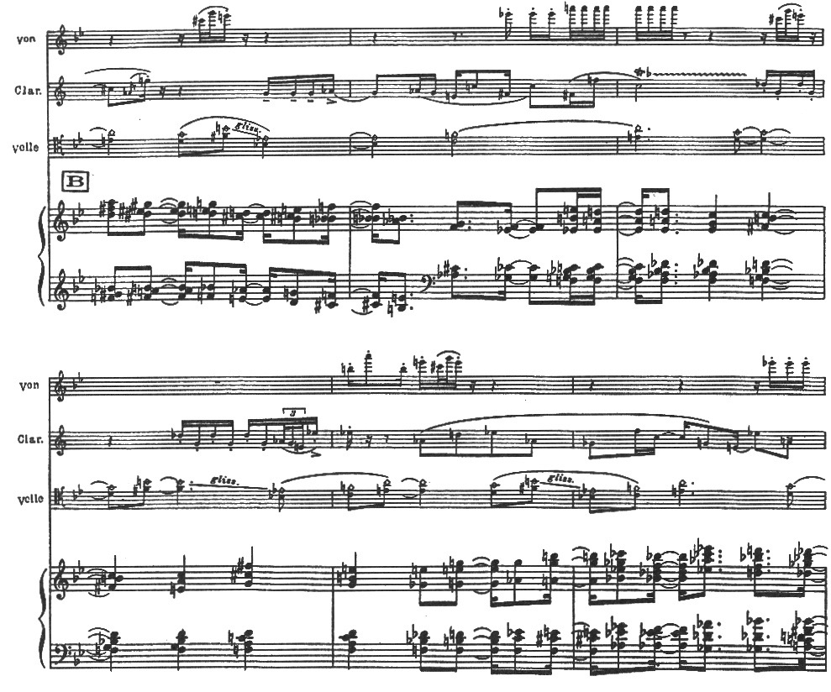

**Figure 1: Oliver Messiaen, *Quatuor pour la fin du temps,* ‘Liturgie de cristal’**

This is managed through conventional notation, so the four instrumentalists do have to play rhythmically together and coordinate. However, the character of each instrument’s notated material is distinct (consider the register/timbre, rhythmic characteristics and pitch) and suggests independence. By contrast *Dance de la fureur, pour les sept trompettes* is entirely in rhythmic unison (Figure 2).

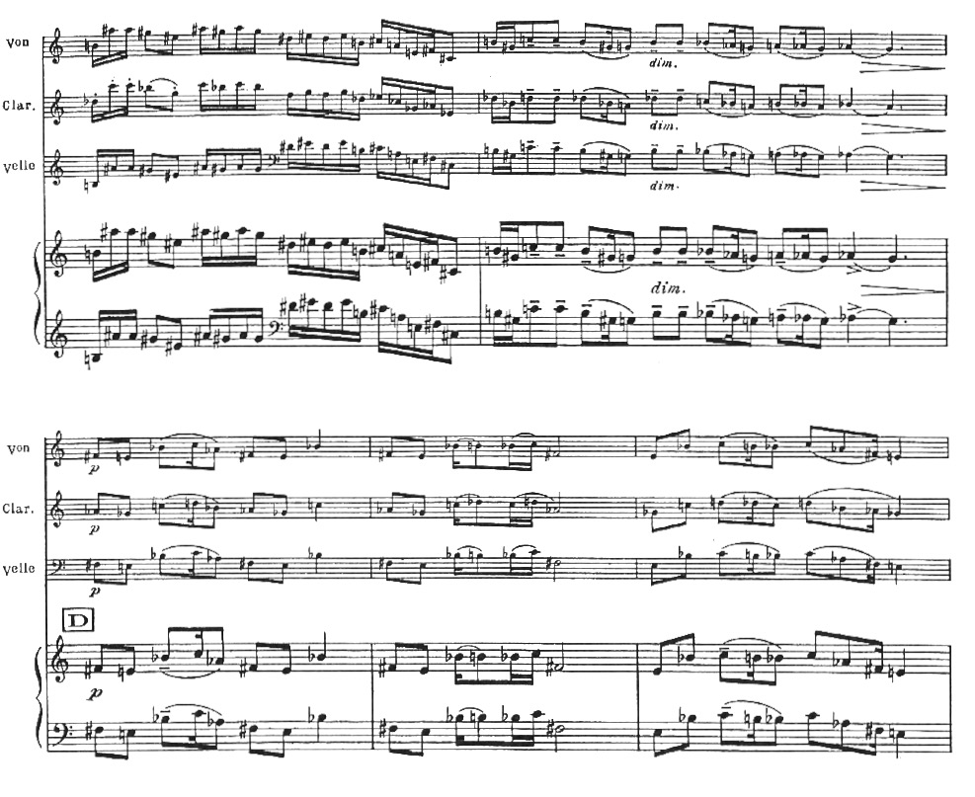

**Figure 2: Oliver Messiaen*,* *Quatuor pour la fin du temps*, ‘Dance de la fureur, pour les sept trompettes’**

These two movements in particular, along with the third *Abime des oiseaux* for solo unaccompanied clarinet, seem to provide useful points of reference for unambiguous instrumentalist behaviours throughout the piece. Elsewhere in the piece interactive relationships are no less clear, if less straightforward. *Louange à l’Éternité de Jésus* and *Louange à l’Immortalité de Jésus* are scored for cello and piano and violin and piano respectively. In both movements the piano has an accompanying role and simply and metronomically marks the passage of time. In other sections of the piece these kinds of relationships are juxtaposed or otherwise intertwined (Figure 3). This is an emergent theatrical narrative based on the behaviour, in relation to coordination and interaction, of the four instrumentalists.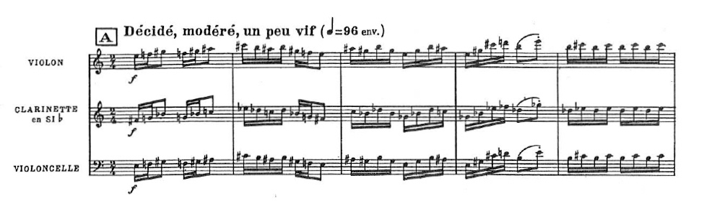

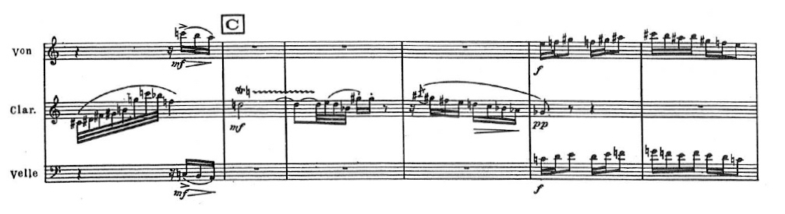

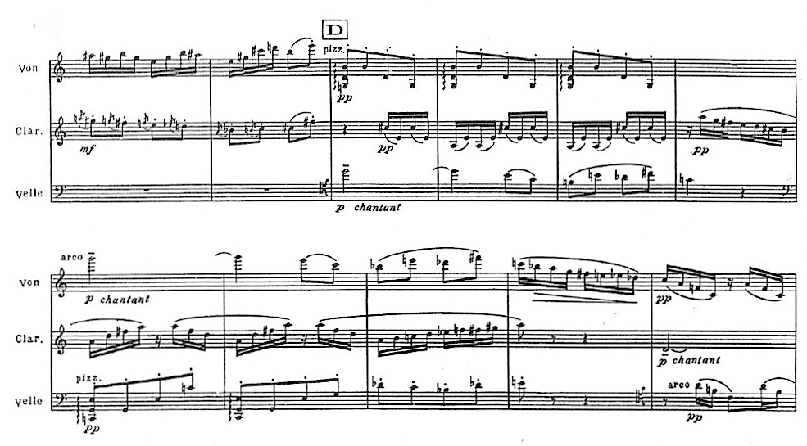

**Figure 3: Oliver Messiaen*,* *Quatuor pour la fin du temps*, ‘Intermède’**

**(three extracts)**

I had observed a similar, if less accomplished, approach in an older work of my own. *Skeins* is a four-movement work for alto saxophone and piano written in 2006. In this piece, particularly in the first two movements, there is a tension between issues of coordination and other compositional parameters. The first movement is, for the most part, syntactically cluttered with a wide variety of durations, rapid changes of time signature and frequent moments of precise coordination between the two players often shifting between being off and on the beat (Figure 4).

In contrast the intended climatic moment of the movement (at least in terms of harmonic density, dynamic and perceived sonic tension) is in direct contrast with this ‘coordination tension’; at this point the relationship between the two instruments is at its most relaxed with ample time to prepare for the two main chords, both on clear downbeats, and are immediately followed by the most sustained piano independence in the movement (Figure 5).

Alphonse:Users:larry_goves:Documents:teaching:RESEARCH:New Coordination Paper:SkeinsMvt1Bars3-10_0003.eps

**Figure 4: Larry Goves, *Skeins*, first movement bb.3-10**

**Alphonse:Users:larry_goves:Documents:teaching:RESEARCH:New Coordination Paper:SkeinsMvt1Bars66-71_0006.eps**

**Figure 5: Larry Goves, *Skeins*, first movement bb.66-71**

In the second movement the relationships are more complex. The pianist is either playing notes simultaneously with the saxophone (usually a quartertone different, the same or, in context, complementary) or is playing almost entirely rhythmically independently from the saxophone (Figure 6). For example, in bar seven the irrational rhythm 6:5 undermines the crochet pulse.

**Alphonse:Users:larry_goves:Documents:teaching:RESEARCH:New Coordination Paper:SkeinsMvt2Bars5-8_0009.eps**

**Figure 6: Larry Goves, *Skeins*, second movement bb.5-8**

However, having seen the piece performed now on numerous occasions, it is not the frenetic ending of the movement that comes across as the focal moment, it is a section about two thirds of the way through where the necessity for close communication is the most demanding. Here (Figure 7) it is the frequency with which the piano coincides with the saxophone and moments where very quiet piano notes coincide with loud saxophone at the apex of a pitch shift, which demands such close communication between the two players. This, in combination with the increased pace of this relationship, creates, I find, more tension than the frenetic activity at the end of the same movement. The final two movements, while more straightforward, continue this approach. The third is unaccompanied saxophone, a clear albeit straightforward duo relationship, and in the final movement the two instruments behave as one throughout. The music is faster but overtly more straightforward in terms of interaction and coordination and more relaxed than the entwined dialogue of the first two movements.

**Alphonse:Users:larry_goves:Documents:teaching:RESEARCH:New Coordination Paper:SkeinsMvt2Bars17-25_0011.eps**

**Figure 7: Larry Goves, *Skeins*, second movement bb.17-25**

I have written a number of pieces that, like *Skeins*, seek to problematise the communication between the performers in stage in order to contribute to the sound and theatre of the music. In particular a number of piece that are dominated by material played in rhythmic unison, often simple melodies. In one typical example, *for Jess & Anna (2)*, three instrumentalists play a simple line in unison (Figure 8). However, the instrumentalists are spatialised making it more difficult for them to see and hear each other. The performers can either exaggerate their physical movements, alter they dynamic to take the lead or follow another player, and/or accept subtle performance discrepancies in the unison line (usually, given the number of repetitions, a combination of all three). Each of these simple pieces is also made to exist alongside another sounds or media, often created collaboratively and therefore quite unrelated to the original[[8]](#footnote-9) component further problematizing the performers’ coordination.

**Alphonse:Users:larry_goves:Documents:teaching:RESEARCH:MuSA Coordination Paper:Music extracts:forJessandAnna2_system3_0002.eps**

**Figure 8: Larry Goves, *for Jess & Anna (2)*, bb.24-29**

A more elaborate example employs the coming together and separation of performer groups within and ensemble through a variety of juxtapositions in order to highlight an instrumental-theatre narrative throughout the work. The seven-performer chamber work *A glimpse of the sea in a fold of the hills*, opens with and has periodic sections of melodic unison for the entire ensemble. This is juxtaposed with sections where the group splinters off into smaller groups where one group performs in unison or closely related material and the other performs the anthesis. For example, in Figure 9 the clarinet follows one of the piano lines while at letter D a quintet playing more pointillist material is triggered (Figure 10) and the two group play independently of each other. The compositional decisions are, in part, emergent from these theatrical considerations and the drama and sound of the music is affected by these changing co-ordinations throughout the piece.

The sound of this music is, in part, emergent from theatrical considerations within these relationships both in terms of the drama and the sound-material being designed around clear cueing and coordination.

Alphonse:Users:larry_goves:Documents:teaching:RESEARCH:MuSA Coordination Paper:Music extracts:glimpse_bars32-37_0005.eps

**Figure 9 Larry Goves, *A glimpse of the sea in a fold of the hills*, bb.32-37**

Alphonse:Users:larry_goves:Documents:teaching:RESEARCH:MuSA Coordination Paper:Music extracts:glimpse_bars1b-3b_0007.eps

**Figure 10: Larry Goves, *A glimpse of the sea in a fold of the hills*, bb.1b-3b**

This sound and theatre are further confused by a sequence of pre-recorded sections for the same instruments that highlight the differences between the clear visual cueing on stage and pre-prepared music where performance coordination is irrelevant. The culmination of the piece is in three sections that serves as the natural theatrical consequence of this approach: a section where melodic lines and the more complex/elaborate horizontal textures come together in a single coordinated tempo; a section of music which is comparable but only electronic (where, for the first time, the entire ensemble is still) and; a final unison line where players drop out sequentially. In these pieces the compositional considerations of sound and theatrical coordination are increasingly entwined.

While these compositional approaches create theatre out of chamber music co-ordinations and lead to particular decisions regarding compositional materials, I wanted to find ways in which performer coordination could have a more tangible impact on the sound of a piece. In a short work for voice, prepared cello, and flute - *Getting into the car on the South Side of Main Street…* - the aspiration for coordination falls outside of traditional chamber music notation and instigates considerable variety to the sound. It is a setting of a section of Matthew Welton’s repetitive poem *Dr Suss* which is a response to Simon Patterson’s celebrated lithograph *The Great Bear* (in which the London Underground stations are replaced on a map with proper nouns themed by line)*.* In Welton’s response each sentence (one for each underground station on any given line) of the twelve poems (one for each underground line) is identical except for one change from the Patterson (alphabetised) and one from Welton himself. For example, the opening of the third poem reads:

*Getting into the car on the south side of Main Street, ‘It’s just a lot of cold treacle,’ was all Filippino Lippi would say. Getting into the car on the south side of Main Street, ‘It’s just a lot of lumpy treacle,’ was all Flanagan and Allen would say. Getting into the car on the south side of Main Street, ‘It’s just a lot of bad treacle,’ was all Fontana would say…* [[9]](#footnote-10)

About two thirds of the rhythmic material for the piece is entirely based on the natural rhythm of speech. Taking a sequence of extracts: towards the opening (Figure 11) the music is dominated by the speech rhythm from the vocalist which provides cues for the two instrumentalists. On each repetition the vocalists removes one syllable which is replaced by either the flautist, the cellist, or both of them. Inevitably trying to fill these gaps creates variable rhythms and this depends on which player (or both players) replace(s) the syllable. This interaction is particularly pronounced about halfway through the movement (Figure 12). As the piece comes to a close to and the two instruments now dominate the speech-rhythm music the sound is also altered; this is a combination of their memory of the vocalist’s rhythm, their own speech rhythm and their attempt to coordinate their speech rhythms precisely (Figure 13).

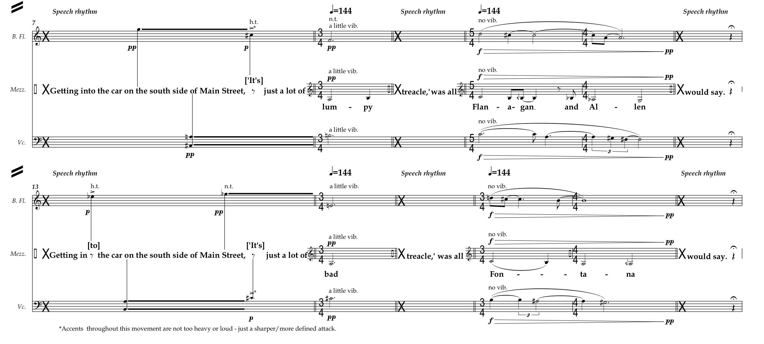

**Figure 11: Larry Goves, *Getting into the car on the south***

***side of Main Street…* , bb.7-18**

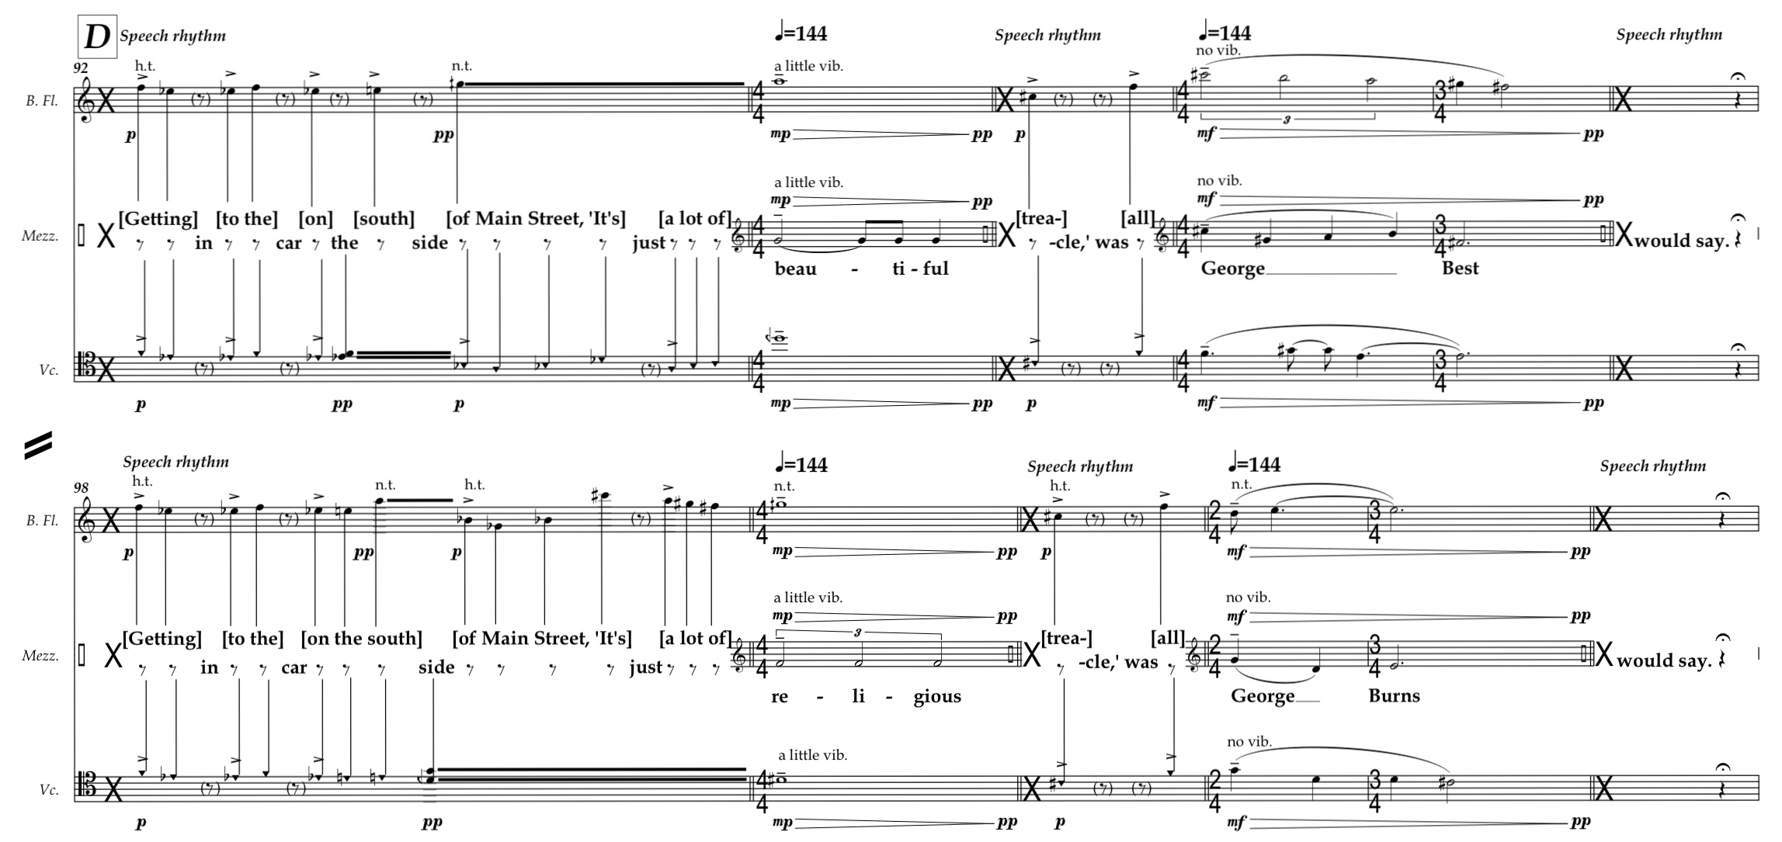

**Figure 12: Larry Goves, *Getting into the car on the south***

***side of Main Street…* , bb.92-103**

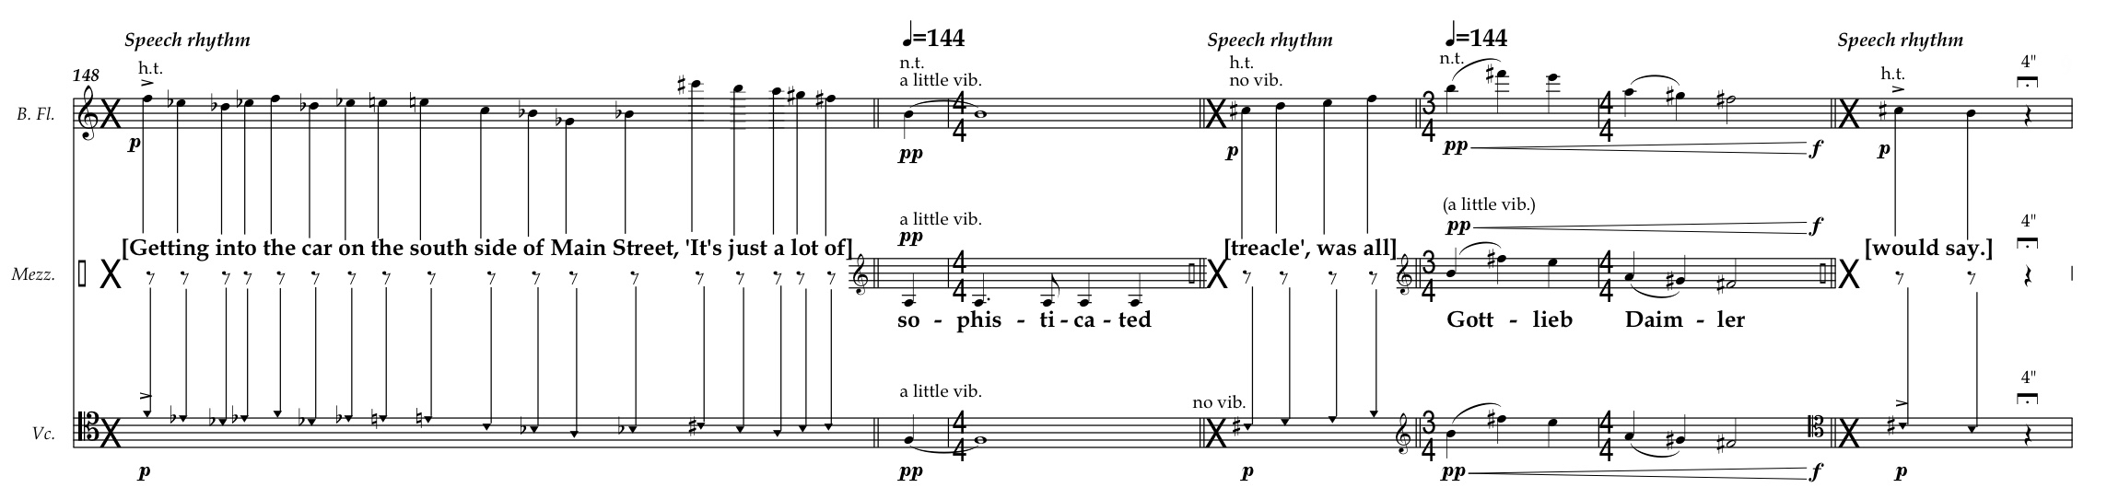

**Figure 13: Larry Goves, *Getting into the car on the south***

***side of Main Street…* , bb.148-154**

Despite the very simple mechanism at the heart of the piece the ensemble interaction here requires a creative engagement from the performers, is not improvisation and, particularly in the middle of the work when there is more back-and-forth between spoken words and pitches, far more potential for unknown/surprising rhythm and pacing.

These approaches culminate in a recent work for two saxophones and electronic sounds, *The Two from Rastibon could start a hailstorm* (2017). As in the previous example the coordination between the players provides the structural basis for the work but here the situation is less formulaic and structurally severe. The piece emerges from two related starting points; the first is to put the sound of the music and the instrumental theatre (in terms of coordination) in a state of play and the second is to engage different notational approaches as a starting point to more precisely consider and control multi-modal coordination (in this case referring to a wide range of aural and physical cueing typical of both most group music making and conversation). This notation, as with the previous example, employs text to indicate rhythm, here borrowing extracts from the script of Lars Von Trier’s controversial film *Antichrist* (from which the piece takes its title). I chose this film as it suited my needs well: I wanted a spoken drama with two characters; drama that includes conversation, argument, soliloquy and religious or quasi-religious chant or mantra and; a drama in which the two protagonists begin entwined (in this case emotionally and, at the start of the film, literally physically) and end up more distant and separate. It is worth noting, as it is such a notorious feature Von Trier’s work, that the sexually explicit violence is not a concern of the piece although I do find the extreme imagery, juxtaposition of the beautiful and the horrific, and the overall trajectory of the film inspiring.

The piece employs three different approaches to notation with particular reference to rhythm: conventional notation; space-time notation and ‘speech’ notation (similar to *Getting into the car on the south side of Main Street…* but here exclusively in connection with instrumental sounds; there are no speech vocalisations from the performers). I loosely identified a number of different interactions for each of these notations; simple and complex approaches to unison, partially playing together, and not playing together. I have created loose categories for this as four sonic states of sonic coordination (high (H), medium (M), low (L) and none (0)) and for each of these sonic states I have, again loosely, decided on a one to five scale in relation to visual/theatrical coordination. These do not always correspond, for example: simple and complex unison will always sound coordinated although complex unison will require more visual coordination between the performers; conversely when the two performers and not playing together the music will never sound coordinated but will required high levels of visual coordination when the notation is complex or none if they’re performing entirely independently.

**COORDINATION CATEGORY SONIC COORDINATOIN VISUAL COORDINATION**

Conventional notation:

Unison (simple) H 3

Unison (complex) H 5

Partially together (simple) M 2

Partially together (complex) M 4 Not together (simple) L 2

Not together (complex) 0 4

Not together (independent) 0 1

Time-space notation:

Unison (simple) H 4

Unison (complex) H 5

Partially together (simple) M 3

Partially together (complex) M 4

Not together (simple) L 3

Not together (complex) 0 5

Not together (independent) 0 1

Speech notation:

Chant H 5

Conversation M 3

Argument M 2

Soliloquy 0 1

**Figure 14: *The two from Rastibon could start a hailstorm,* categories and degrees of sonic and visual coordination**

The structure of the piece, divided into four sections suggested by the four acts of *Antichrist*, has the players gradually move from visually/theatrically coordinated to visually/theatrically independent (Figure 15). The sound, however, does not follow this trajectory and so the visual and sonic exist in a state of play. The intention is that the discrepancies in this ‘coordination tension’ will serve to create momentum in the music as the sonic and physical synchronize behaviours at the end of the piece, as well as well as contributing to the musical character of each of the four sections.

**COORDINATION CATEGORY SONIC COORDINATOIN VISUAL COORDINATION**

**Section one:**

Conventional notation:

Unison (complex) H 5

Time-space notation:

Unison (complex) H 5

Not together (complex) 0 5

Speech notation:

Chant H 5

**Section two:**

Conventional notation:

Partially together (complex) M 4

Not together (complex) 0 4

Time-space notation:

Unison (simple) H 4

Partially together (complex) M 4

**Section three:**

Conventional notation:

Unison (simple) H 3

Time space notation:

Not together (simple) M 3

Not together (simple) L 3

Speech notation:

Conversation M 3

**Section four:**

Conventional notation**:**

Partially together (simple) M 2

Not together (simple) L 2

Speech notation:

Argument M 2

Conventional/time-space/speech notation:

Independent/soliloquy 0 2

**Figure 14: *The two from Rastibon could start a hailstorm,* sequential organization of the piece with regard to sonic and visual coordination**

Towards the start of the piece, therefore, the music consistently demands close multimodal communication between the players. Bars 2-10 (Figure 15), a fragment of traditionally notated ‘complex’ unison, contains features that force close communication between the saxophonists: a wide variety of different bar durations; a relatively complex rhythmic vocabulary within these bars; a requirement to ‘pass’ certain pitch unisons from one player to the other (shown by the dashed diagonal lines); and a number of that temperamentally require a temperamentally variable moment to speak.

Alphonse:Users:larry_goves:Documents:teaching:RESEARCH:MuSA Coordination Paper:Music extracts:System 2_0001.eps

**Figure 15: Larry Goves, *The two from Rastibon could***

***start a hailstorm*, bb.2-10**

In the following bars (Figure 16) the time-space notation is based on ‘complex’ interactions where the players are completely unsynchronized. However, they are required to cue the other player’s notes (the vertical arrows) which are all slightly different lengths, ensuring again, considerable gestural and communicative interaction.

Alphonse:Users:larry_goves:Documents:teaching:RESEARCH:MuSA Coordination Paper:Music extracts:System 3_0001.eps

**Figure 16: Larry Goves, *The two from Rastibon could***

***start a hailstorm*, b.11**

In the following three systems, the final part of the first section of the piece, the notation is designed around ‘chant’ in which the two players briefly establish their own rhythmic approach to a line of verse spoken in the film (apparently quoting or paraphrasing Homer’s description of the mythical Chimera) which over the course of three repetitions requires the two players to play this speech rhythm in unison (Figure 18).

Alphonse:Users:larry_goves:Documents:teaching:RESEARCH:MuSA Coordination Paper:Music extracts:System 4+5_0002.eps

Alphonse:Users:larry_goves:Documents:teaching:RESEARCH:MuSA Coordination Paper:Music extracts:System 6_0002.eps

**Figure 17: Larry Goves, *The two from Rastibon could***

***start a hailstorm*, bb.12-16**

This opening serves in sharp contrast to music later in the piece where visual coordination less pronounced. The next three sections of text notation conversation, argument, and soliloquy allow for less and less entanglement between the performers until they, at the end of the piece, perform an extended soliloquy of ‘speech’ notation facing away from each other. This final section is also, perhaps unsurprisingly, the most complex sounding section given the possible rhythmic interplay between two simultaneous but uncoordinated performers. Similarly, latter sections of partially sonically coordinated but simpler notation focus on: simple rhythmic values; consistent bar lengths; more closely related multiphonics (making them easier to performer more consistently); and no requirement to highlight pitches moving between the parts (Figure 18).

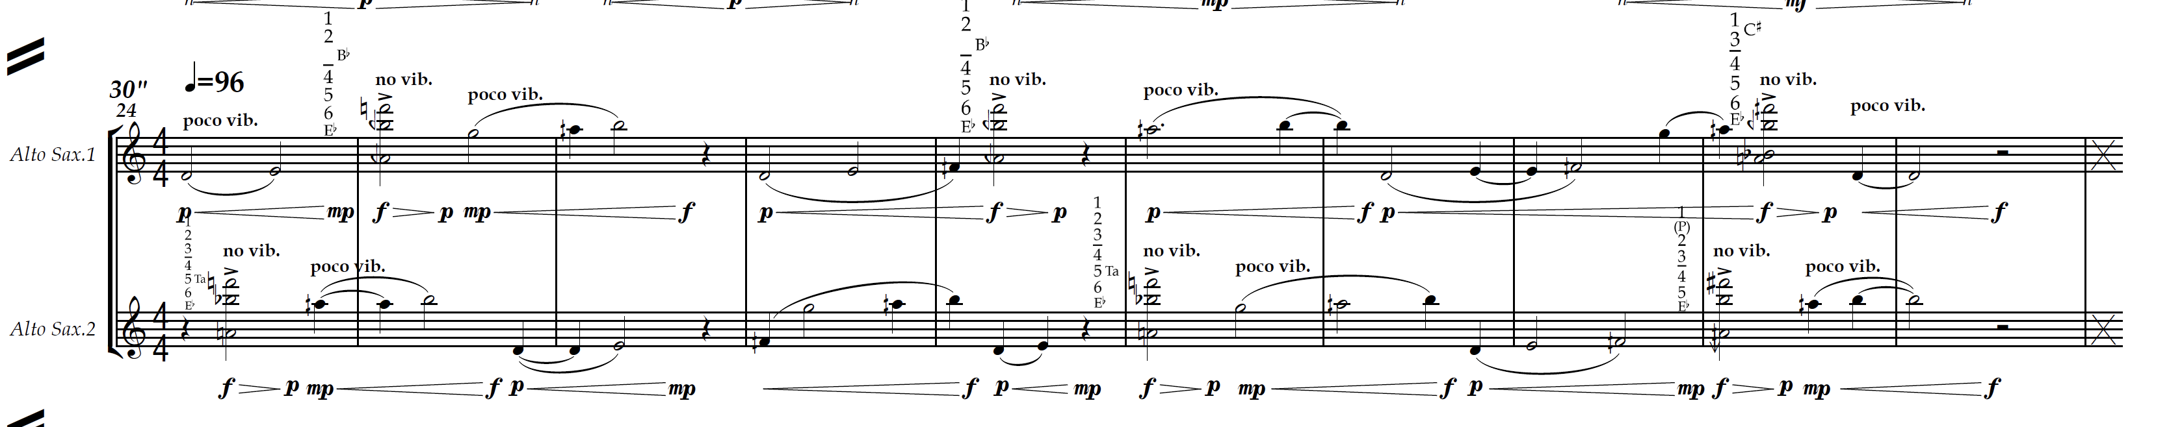

**Figure 18: Larry Goves, *The two from Rastibon could***

***start a hailstorm*, system 24**

I have questions over the success of this approach, at least from the literal coherent visual structing of the work as a journey from coordinated to unsynchronized, as there as so many nuanced communication issues, many likely to be idiosyncratic to any given performer and duo. During the premiere there were sections where the simpler notation did indeed lead to fewer physical performer cues, although other comparable sections seemed to generate more performer movement as a result of the music being more straightforward and perhaps comforting to easily visually cue. However (and noting that I cannot separate this from my intimate knowledge of the piece and of chamber music performance practice), it always seemed evident when performer cueing was absolutely necessary and emerging from the music and when it was a performer decision and placed onto the music. The theatrical compositional aspiration here is to take ownership of nuances typical of performance practice. While the theatrical trajectory may not be clear the visual communicative language of the music is foregrounded and the decision to prioritise this during the compositional process has led to both particular organisation of sounds and an inherently unstable sequence of sounds and interactions.

Throughout this work (alongside another sequence of pieces primarily concerned with projected text), particularly in reference to the ‘speech’ notation, I was influenced by Horatiu Radulescu’s approach to rhythm in his Fifth String Quartet *‘before the universe was born’*. Here he writes English translations of extracts from Lao-Tzu’s *Tao Te Ching* above each page so that the phonetic rhythm can inform the rhythm of the music with symbols to indicate levels of synchronicity. In his article analysing the quartet William Dougherty observes that ‘Radulescu wanted a deep unity – a synthesis between the written text, its philosophical meaning, and the rhythm generated from articulating the text phonetically – that would transport the performer into a special state of awareness.’[[10]](#footnote-11) Although I’m enticed by the implied entanglement of the writing, symbolism, rhythm, sound, communication, ideas, and spiritualism that Radulescu implies in the performance notes to his quartet (Figure 19), my own attitude and approach is more prosaic where I have been drawn to studies that map the subtlety of these coordination issues.

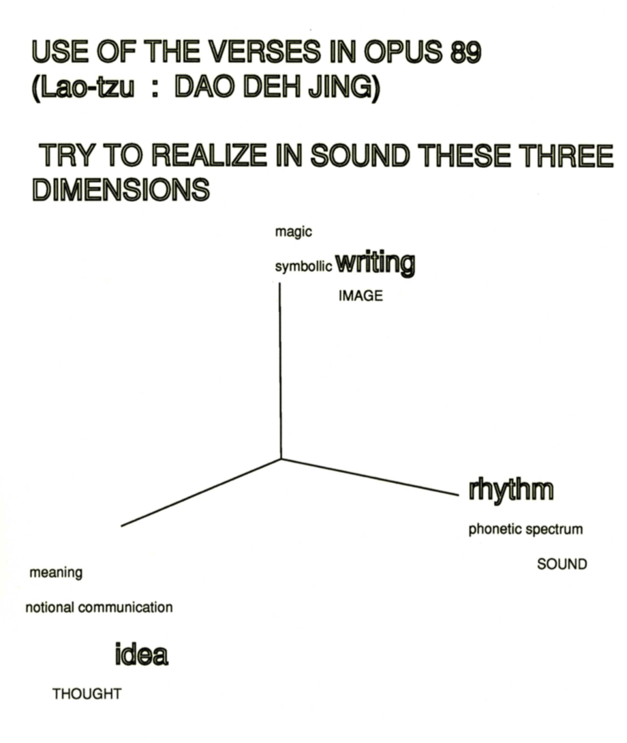

**Figure 19: From performance notes from the score of**

**Radulescu’s Fifth String Quartet**

The subtlety of this communication has been extensively explored. In a series of experiments conducted by psychologists and musicians, led by psychologist Professor Alan Wing, small variations in asynchrony between two professional string quartets (in standard ‘classical’ repertoire) and the amount of time this took to correct this was scrutinised. In this study the standard deviation (averaged over 15 repetitions) was 25 milliseconds for one quartet and 16.7 milliseconds for the second.[[11]](#footnote-12) Despite these tiny discrepancies they were able to draw differing conclusions about the responsive behaviours of each quartet suggesting that the ‘correction patterns may be seen as reflecting contrasting strategies of first-violin-led autocracy versus democracy.’[[12]](#footnote-13) In a related paper arguments are made for audience perception of these small asynchronies. [[13]](#footnote-14)

My own reading is that these empirical studies of coordination complement the notion of Radulescu’s ‘special state of awareness’; I would consider this state as a necessity for the nuanced and entangled performance practice tropes of multi-modal communication that allow for this degree of detailed coordination. These are the features of live performance that are easy to identify but difficult to codify: movement of great variety and degrees of emphasis (posture/gesture etc.); eye contact; sonic emphasis; language; and listening as well as shifting notions of leadership and deference necessary for error correction and aspirations coordination. Alan Wing and his team observe, ‘social groups frequently engage in activities which involve coordination of timing between group members’[[14]](#footnote-15) and ‘coordination of movement to an external rhythmic auditory stimulus is a wide-spread biological phenomenon… and possibly related to vocal mimicry abilities.’[[15]](#footnote-16) This sequence of pieces seeks to highlight these relationships within the stylised case study of chamber music performance practice and, in doing so, celebrates the *aspiration* of coordination, the emergent discrepancies, and the positive qualities of nuanced human ‘error’ over sterile notions of perfection and accuracy.

1. Björn Heile, ‘Towards a Theory of Experimental Music Theatre; “Showing-Doing,” “Non-Matrixed Performance,” and “Metaxis” in *The Oxford Handbook of Sound and Image in Western Art*, ed. by Yael Kaduri (Oxford: Oxford University Press, 2016), pp. 342. [↑](#footnote-ref-2)
2. Jenny Gottschalk, *Experimental Music Since 1970* (London: Bloomsbury, 2016), p. 188. [↑](#footnote-ref-3)
3. John Cage, *Silence: Lectures and Writings,* 2nd edn (Middletown (Connecticut): Wesleyan University Press, 1973), p. 35. [↑](#footnote-ref-4)
4. Lothar Klein, *The Fugue Interview: Witold Lutoslawski in Conversation* (1979), <http://www.lotharklein.org/files/assets/scores/6e18c4d5c7e9b835cb3b9407097a1984.pdf> [accessed 6 June 2019]. [↑](#footnote-ref-5)
5. Ibid. [↑](#footnote-ref-6)
6. Gottschalk, *Experimental Music Since 1970*, p. 189. [↑](#footnote-ref-7)
7. Cage, *Silence, Lectures and Writings*, p.36. [↑](#footnote-ref-8)
8. For example: *for Jess & Anne* was combine live electronic improvisation with Bill Thompson and myself; *for Jess & Anna (2)* for spatialized pre-recorded sound as part of collaborative perceptions experiments with neuroscientist Dr Beau Lotto; *onn/off* was written for live/pre-recorded electronics by mira calix; and *Music for Virtual Airports* was originally written to go alongside spatialized films by Netia Jones. [↑](#footnote-ref-9)
9. Matthew Welton, *We needed coffee but we’d got ourselves convinced that the later we left it the better it would taste, and, as the country grew flatter and the roads became quiet and dusk began to colour the sky, you could guess from the way we retuned the radio and unfolded the map or commented on the view that the tang of determination had overtaken our thoughts, and when, fidgety and untalkative but almost home, we drew up outside the all-night restaurant, it felt like we might just stay in the car, listening to the engine and the gentle sound of the wind*, (Manchester: Carcanet Press, 2009), p. 82. [↑](#footnote-ref-10)
10. ­William Dougherty, ‘On Horatiu Radulescu’s Fifth String Quartet (‘before the universe was born’) Op.89’, in *Tempo 68* (268) (2014), p.37 [↑](#footnote-ref-11)
11. Alan M Wing, Satoshi Endo, Adrian Bradbury, Dirk Vorberg, ‘Optimal feedback correction in string quartet synchronization’, *J.R.Soc.* *Interface* 11: 20131125 (2014), http://dx.doi.org/10/1098/rsif.2013.1125 [↑](#footnote-ref-12)
12. Ibid., p.1 [↑](#footnote-ref-13)
13. Alan M Wing, Satoshi Endo, Tim Yates, and Adrian Bradbury, ‘Perception of string quartet synchronization’, *Frontiers in Psychology* Vol.5 1115 (2014). https:doi.org/10..3389/fpsyg.2014.01115, p.1 [↑](#footnote-ref-14)
14. Alan Wing etc al, *Optimal Feedback correction in string quartet synchronization*, p.1 [↑](#footnote-ref-15)
15. Ibid. [↑](#footnote-ref-16)